Evaluation of the Summer Playscheme 2018 in Winsford
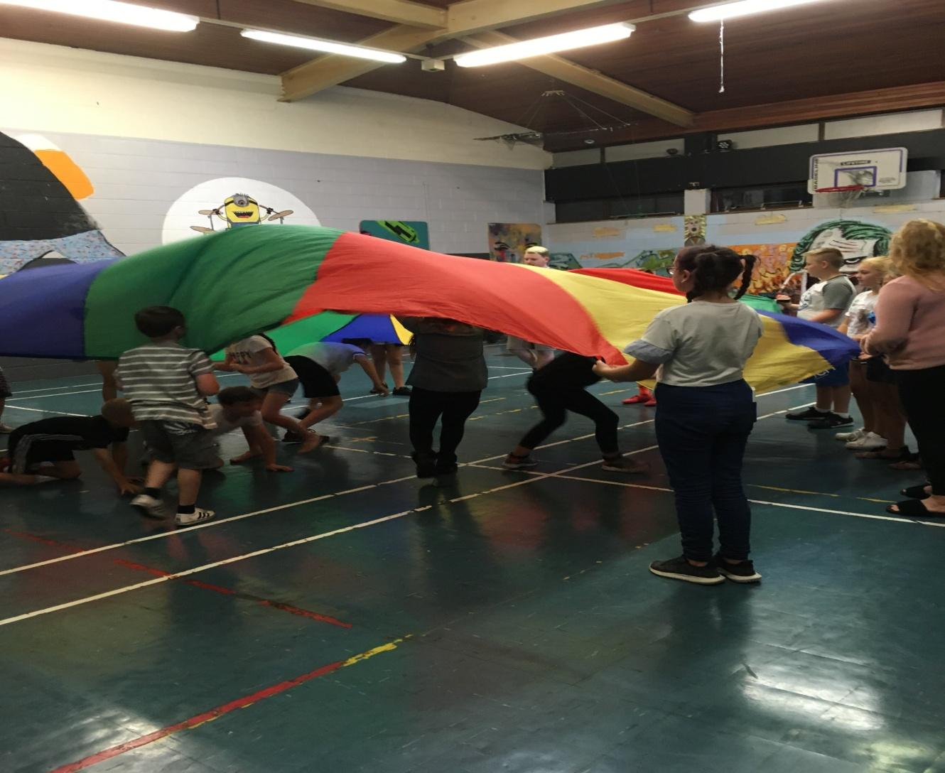
The parachute game

Executive Summary

Winsford Youth and Community Forum (WYCF) has a long history in coordinating Summer Playschemes in Winsford. This year funding was obtained from the Town Council, Cheshire West Members Budget, CrimeBeat, Darnhall Trust and The BBC Children In Need fund; this meant we were able to operate from four sites across the Town. Oak View Academy, New Images Youth and Community Centre, Wharton Community Library and Winsford Marina.

The venues were booked, we recruited and trained ten Play Workers, two of which would take the role of Play Leaders at the two larger sites. All policies and training sessions were amended to adhere to the new Data Protection Act. The risk assessments for each site were revised and all existing resources and equipment audited on each site and new resources order where required.

Marketing materials and parental consent forms were developed and delivered to all local Primary schools, Children's Centre’s, Children's Services Teams, Youth Offending Teams, Cheshire Police, the Fire Service, local community centres, youth clubs, local shops and social media.

At the beginning of the week the numbers of children attending was disappointing, but this is normally the case. Feedback from parents was that they had already arranged a holiday or days out before they knew about the Playscheme. Also the Bio Leisure Centre and West Winsford GGO Community Group were running free events in August.

At Wharton the group were between eight and fifteen for each session. There was some very challenging behaviour from some children and some needed one to one support, so we assigned another member of staff to help address this. At New Images Youth Centre the numbers ranged from fourteen to thirty three and at Oak View Academy four to ten.

The children were asked before the Playscheme, what they expected and again when the Scheme had finished. We also gained feedback from the Play Workers, Parents, workshop provider and staff.

Introduction

Winsford Youth and Community Forum have been delivering Summer Playschemes since 1989 in the Winsford area. This has been achieved with the support of its partners, Cheshire West and Town Councils, Cheshire Police and Fire & Rescue Services, Darnhall Trust, Williams Foundation and local businesses.

From Government figures we know that Winsford has some areas of poverty and this can impact the health of children and young people and their ability to learn. There are few amenities in Winsford, and activities at the Leisure centre can be beyond the financial reach of some families. The Forum provides four Youth Club sessions in Wharton and New Images, two for 8 to 12 year olds and two for 12 to 16 year olds. The Forum has been successful in recruiting a Play Lead Coordinator, funded by the BBC Children in Need fund, to find funding to expand the Playschemes to run in Half Term, Easter and Summer holidays.

The Playschemes are structured to give the Children a range of different experiences and activities in an informal setting to develop their skills, knowledge and confidence. The Schemes give the young people a safe environment to build relationships with other young people their own age and away from other young people that could be a bad influence on them.

Summer Playscheme

During the sessions the children enjoyed a range of activities that included learning to cook, sports, games, arts and crafts and creative drawing. There were also friendly competitions in drawing and pool, with a talent show at the end of the last week. The children are involved in the planning of the sessions and in some cases they run the sessions themselves.

Every child that came to a scheme was encouraged to try new activities and experiences, to treat staff and each other with respect, have fun and develop new skills. We provided a safe and secure environment for the children which were free for everyone. We targeted our advertising to all primary schools and Children's Centres in the area. The funding we received enabled us to operate daily on three sites and the Marina on a Wednesday morning for canoeing.

New Images was a purpose build Youth Centre and still can offer a wide range of activities from badminton, volleyball, pool, table football, rocket ball and dodge ball, the last two being favourites. The Centre has a fully equipped kitchen and during the week ChatterBox cafe opens on a Tuesday and Thursday. This was closed because of the Playscheme, but one of the volunteers who works for ASDA came to the centre on those two days to teach the young people new cooking skills and all of the ingredients were supplied by ASDA. Some of the things they made were French bread pizzas, rice crispy cakes, healthy wraps, cakes and fruit cones.

The Prince's Trust led a session with the young people, where they made egg rockets and kites, which they enjoyed as this was something new to all of them.
The Main Hall at New Images Youth and Community Centre
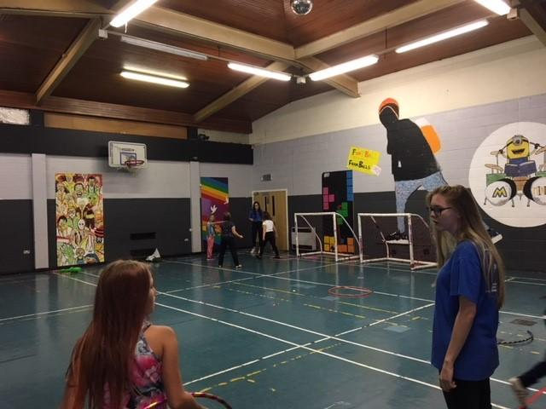

Wharton Community Library Community room is a much smaller venue on the estate of Wharton, it comprises of one large room, a store cupboard, a small kitchen with a microwave.

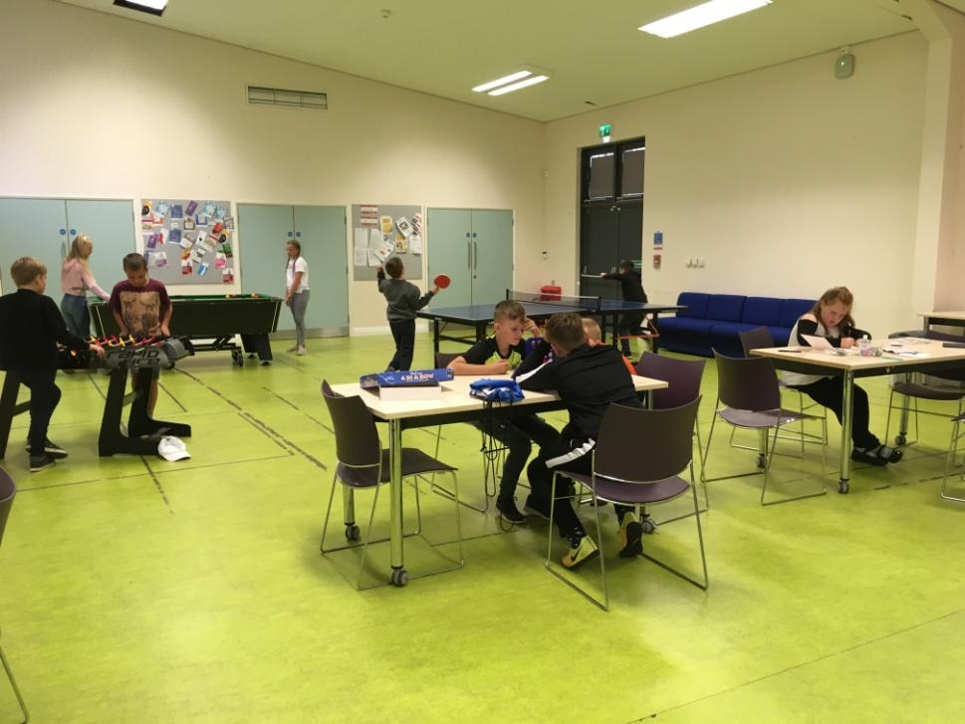

Wharton Library Community Room

Through the Forum’s experience of running the youth clubs on this estate, it was realised that some of the children have a limited concentration span, therefore the timetable was very structured and in most cases each segment was between 30 minutes to an hour long. On average the number of children attending the Playscheme was between 10 and 14 for each session.

Two young people had been banned from the building which meant that they could not attend the playscheme and around five of their friends stayed away too. At first the young people had to be reminded to be respectful and to adhere to the rules, which they had designed, but as the days passed they worked together with staff to help the smooth running of the sessions. The young people were introduced to new games which they were not sure about to start with e,g, tennis football and blink pool, (where each player has three lives and they take it in turns to play until they are out), but once they had played them a few times they began to enjoy them. The children seemed happier when they had a range of activities that they could try out in the session.

The third venue was Oak View Academy, where the Scheme had access to the staff room/kitchen, the main hall, amenities, the playground and the main field. Numbers were low from the beginning, although we carried out a leaflet drop. The fourth week the School was closed so the scheme switched to Over Reformed Church, but numbers remained low despite another leaflet drop.

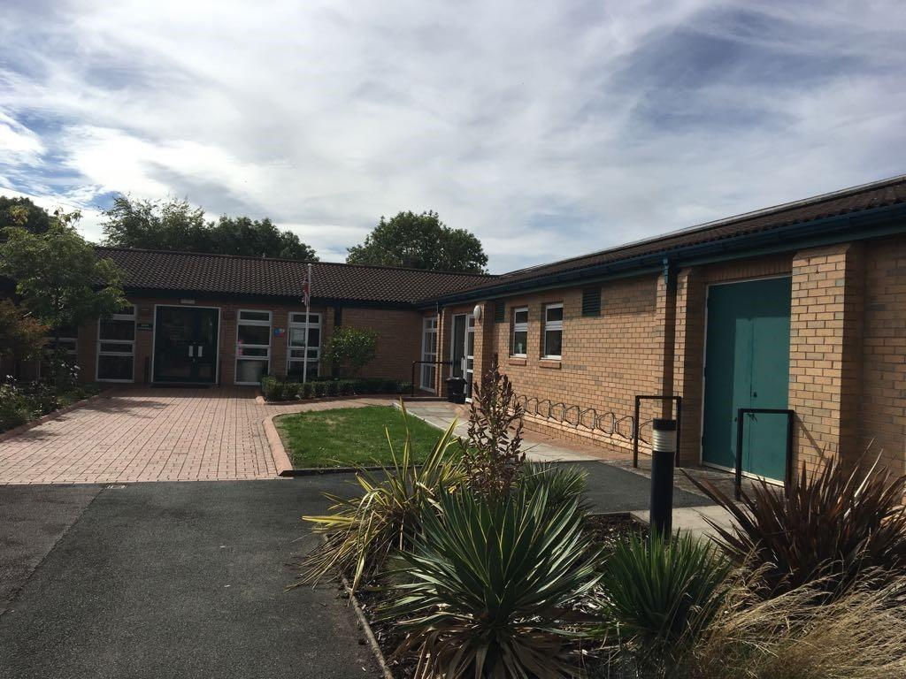

Oak View Academy

The fourth site was Winsford Marina, where young people over 10 years of age, who could swim 25 metres went on a Wednesday morning for canoeing sessions with Qualified Instructors.
Winsford Marina
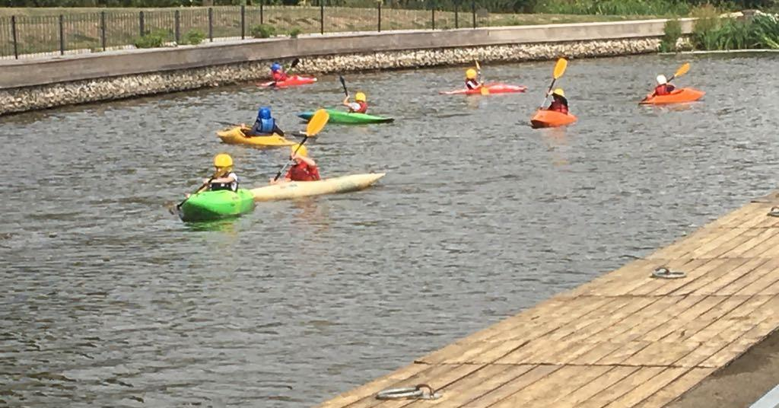

Outcomes
For the children to gain new skills, make friends and to have fun.
To encourage the children to participate and grow as a person.
To develop social skills through informal learning.
To build their self esteem and confidence as a result of the scheme.

Feedback from Play Workers at Wharton

The majority of the group engaged well and were willing to try the new activities and games, the girls especially enjoyed making and colouring the picture of space. Two boys, with the most challenging behaviour, just wanted to play dodge ball, football and pool and were resistant to anything new that they had not tried before, but eventually did engage with support and encouragement.

When asked what they liked about the Playscheme, the children said lots of different things to do and the older ones liked the canoeing. The scheme was planned in advance, we had a timetable that we mostly followed and new resources and crafts for the children to play with and make.

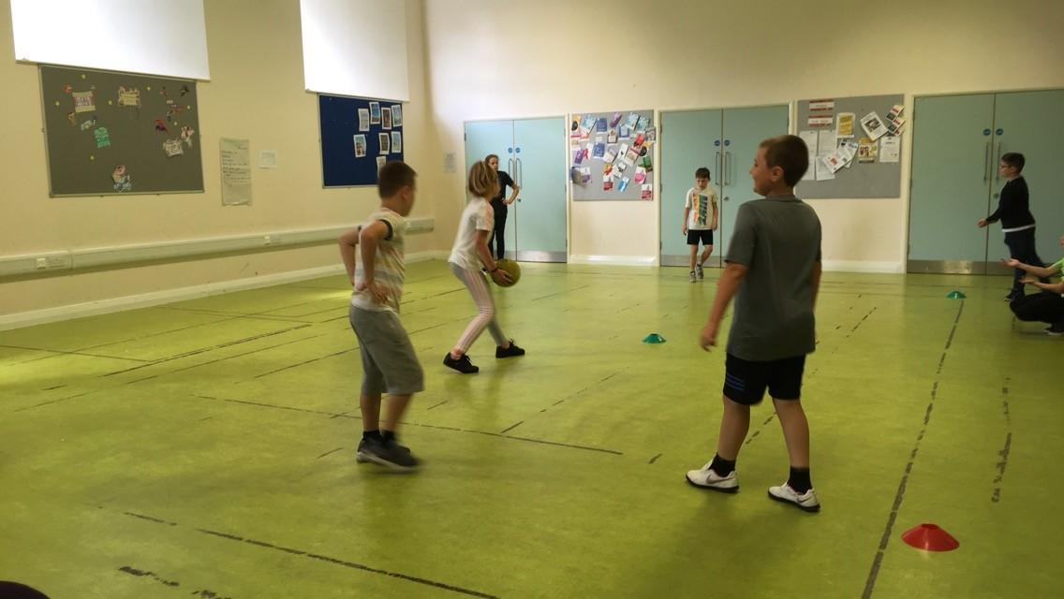

Football rounders at Wharton

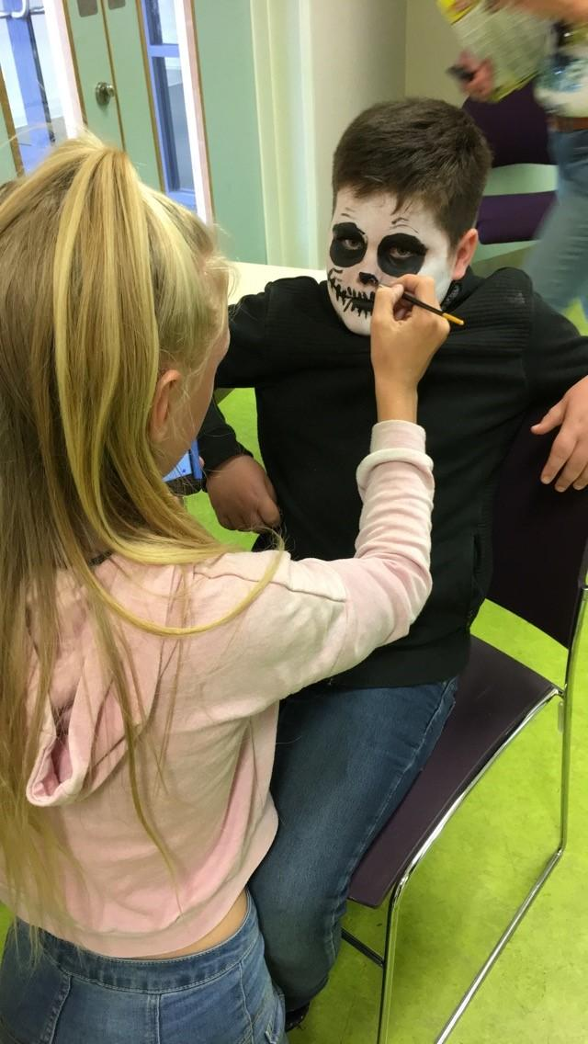
Face painting at Wharton
Making Mars Bar cake

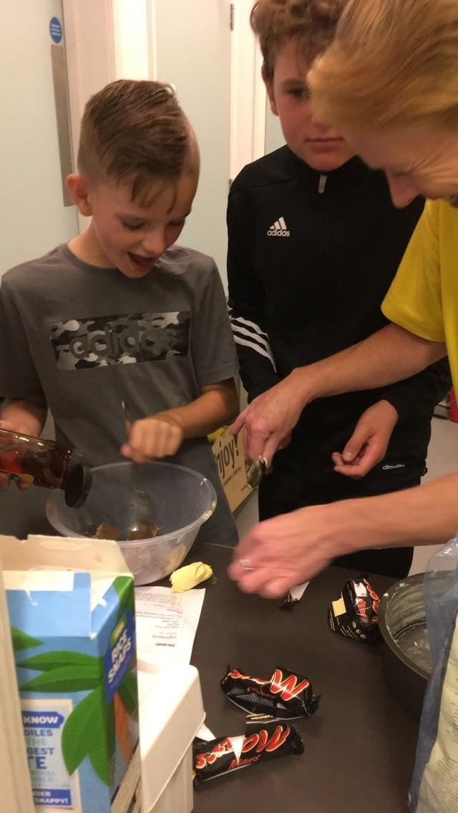

The children desived their own card game
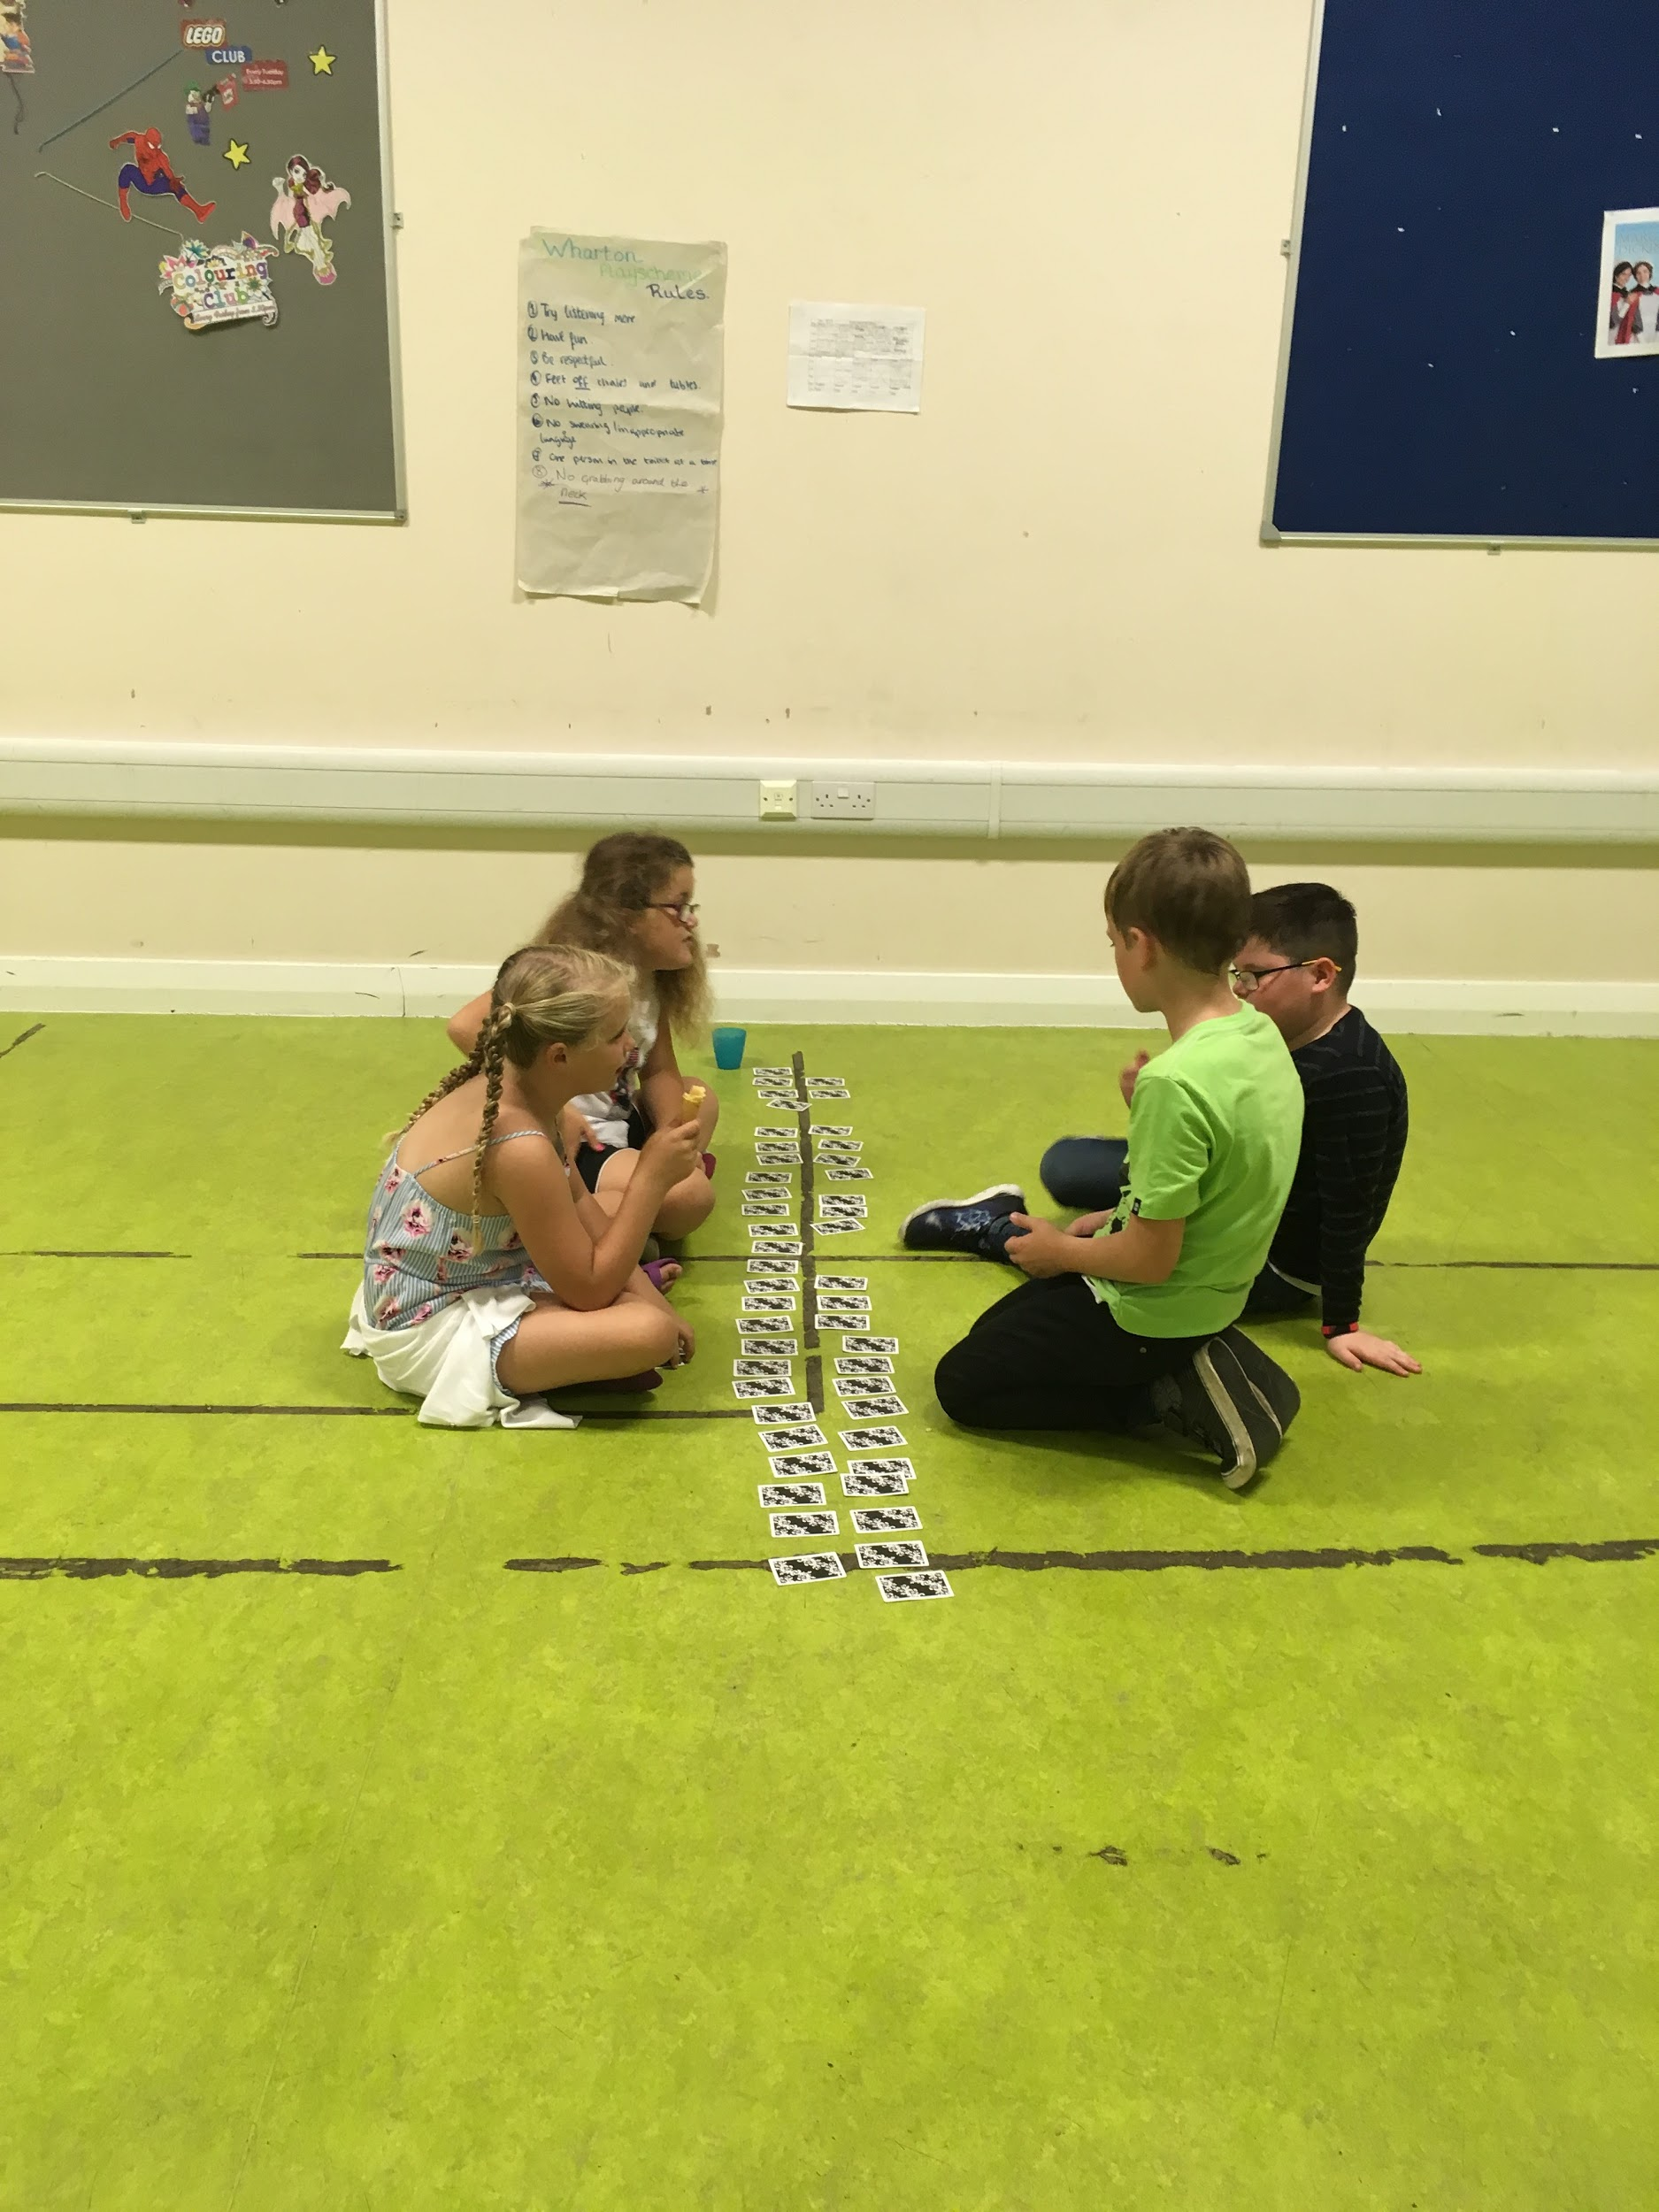

New Images

The young people engaged well on the whole, the girls particularly liked the cooking classes and the arts and crafts. The boys were more interested in the sports like football, basketball, dodgeball and pool.

The play leaders encouraged them to take part in all the activities, which they did. When asked, the children enjoyed the range of activities, cooking, dodgeball and the hungry hippos game. We welcomed the support of the local Police Community Support Officers, who brought old police uniforms for the children to dress up and play cops and robbers, followed by wink murder.

The games room at New Images
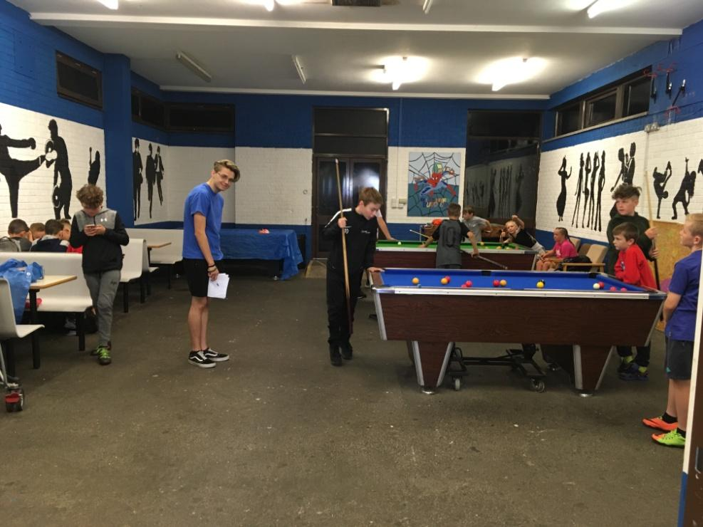
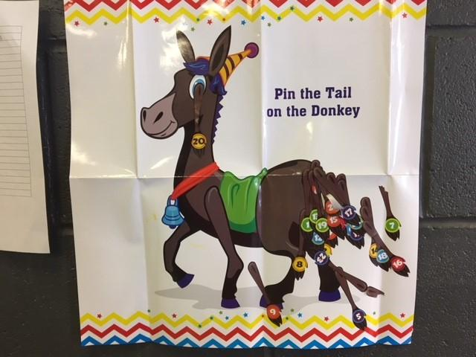

OakView/Over United Reform Church

The low numbers at both the School and the Church meant that the children had more attention from the Play Workers, but one drawback was it was more difficult to play team games like football and hungry hippos.

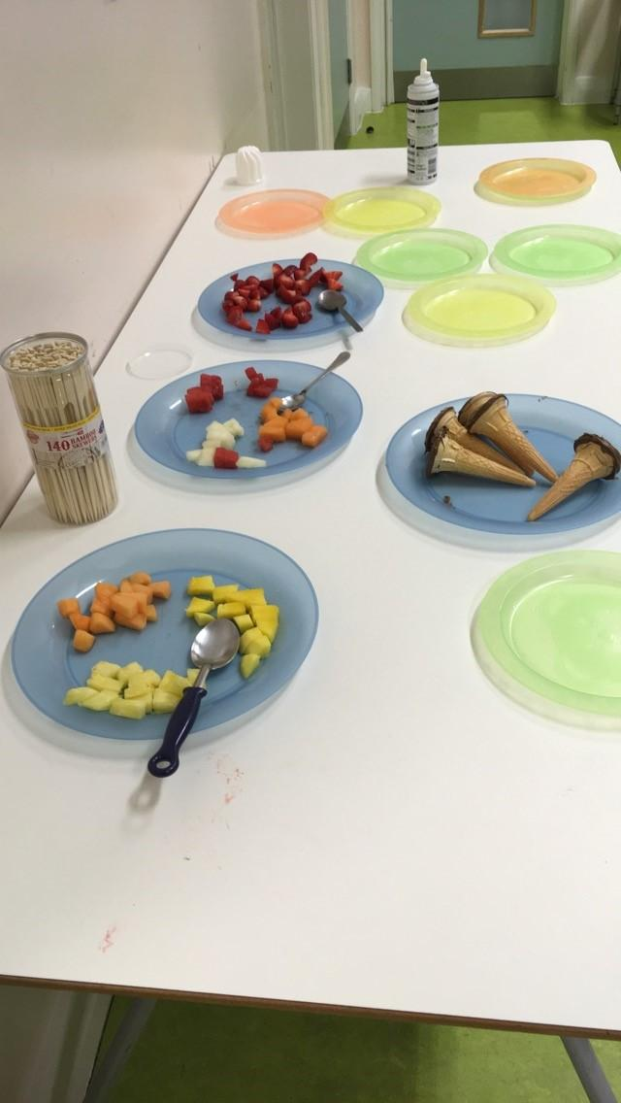
Making Fruit cones at Oak View Academy

Winsford Marina

The young people over ten years old had the opportunity to go canoeing on a Wednesday Mornings. They were introduced to qualified instructors, that helped them with their clothing, equipment and were given a safety briefing before they entered the water. To get used to the canoe and the paddles for the first part of the morning was spent in a siding to the main canal. When Instructors were satisfied they were ready the group took to the main canal and were given tasks to complete including rafting, changing places and with no paddles.
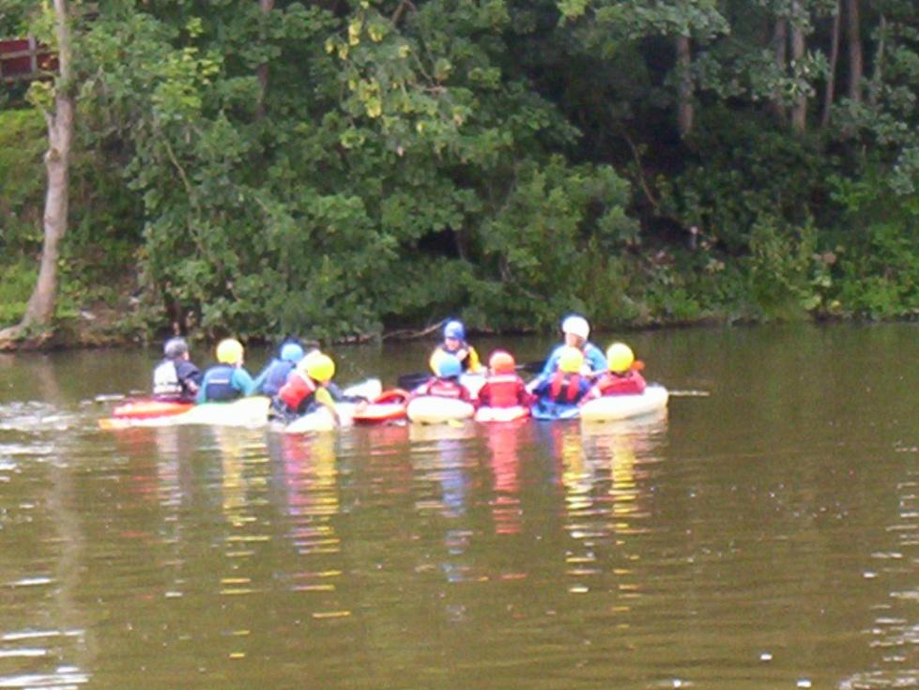
The children at the Marina starting to make a raft

Evaluation

Winsford Playscheme took place at three venues across the Town, we advertised the Scheme through the local primary schools before they broke up for the Summer Holiday. Numbers were lower than anticipated and we feel there was a number of reasons for this. Firstly we had arranged for someone to develop a Playscheme Facebook page, but were let down at the last minute. Although it was advertised on the Forums Facebook Page. We are also experiencing problems with the Forums website, which are still not resolved. Not all the schools gave out the flyers to their children at the end of term and poster in public places were not always seen. Because we had not got all the funding we had asked for we had no external workshops this year. Over the four weeks there were 91 children attended sessions at New Images Youth and Community Centre; 21 at Oak View Academy and 32 at Wharton.

This year there were more activities arranged for children in Winsford in our age range that clashed with what we were trying to provide. The Leisure Centre provided free swimming sessions, also the GGO group in the West of Winsford had lottery funding to put on events throughout August. Darnhall Primary School hosted a two week soccer school which contributed to the low numbers at Oak View Academy. The last week in August many families were on holiday in the UK or abroad.

Conclusions

The play scheme on the three sites did achieve our outcomes for the children to gain new skills, make friends and to have fun. Play Workers encouraged the children to participate and grow as individuals. The children did develop social skills through the games and activities. Their experiences of making new friends and learning new skills helped the young people increase their self esteem and confidence. Feedback from partners, Play Workers, children, parents and staff was that it was a success.

Advertising the Playscheme
In the future to work with all other organisations and groups providing summer activities in Winsford. Design a bigger and more eye catching poster and banners. Develop a Facebook page and publish it on the Forums website, update the pages daily with the days activities. Research where else we can publicise the scheme, partner websites, local newsletters, public buildings.

Recruitment of staff
Use qualifying questions when advertising for staff. Speak to each person on the phone and find out about them as a person before asking them to apply in writing.

Funders
Winsford Youth and Community Forum would like to thank the funders of our Summer Playscheme; Winsford Town Council, Cheshire West Council Member Budget, Crimebeat, the Darnhall Trust, The BBC Children In Need and support from ASDA.
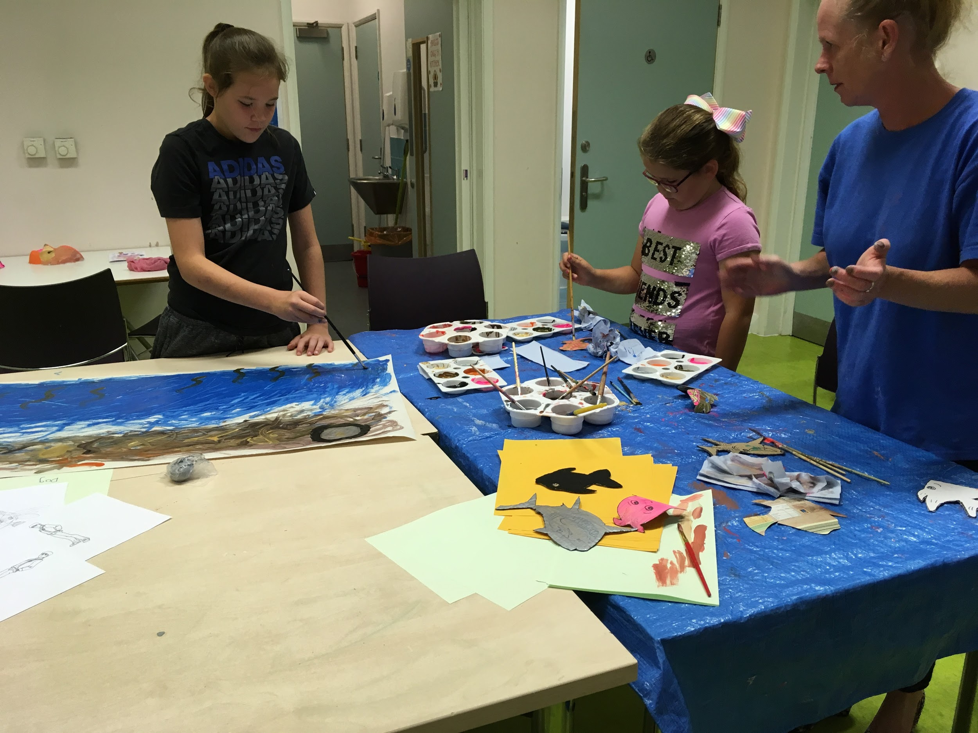
Painting at Wharton

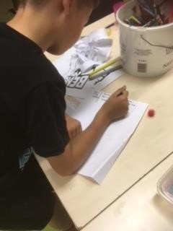
Taking orders at Wharton

