Evaluation of the February Play Scheme in Winsford

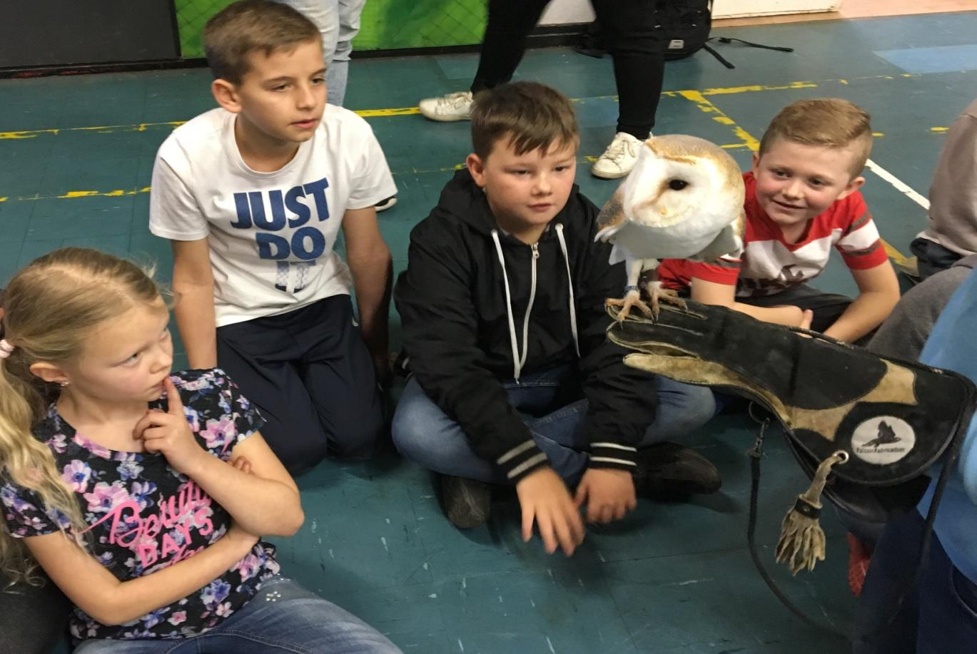

Executive Summary

Winsford Youth and Community Forum have a long history in coordinating Summer play Schemes, but this is the first time the forum has ran a play scheme in the February Half Term. Funding was obtained from the Williams Foundation to run a scheme on two sites, at Wharton Community Library and at New Images Youth Centre.

The Play Lead Coordinator booked the venues, recruited and trained seven Play Workers. The induction handbook was rewritten to bring it up to date with all current legislation, external workshops were reserved and all existing resources and equipment audited on each side and new resources order where needed.

Marketing materials and parent consent forms were developed and delivered to four local schools, Children's Centre’s, Children's Services Teams, Youth Offending Teams, Cheshire Police, the Fire Service, local community centers, youth clubs and shops.

The Play Lead Coordinator networked through local meetings and became a partner in the Winsford Wellbeing week, which was running at the same time. In the week a range of activities were provided for all age ranges and would encourage them to live a healthier lifestyle.

Through sickness two of the Play Workers dropped out at the last minute and we had to find replacement at short notice and the Play Lead Coordinator, Senior Youth Worker and a Trustee all filled in when needed. Each site had its own resources, but some were shared and the Coordinator made sure that the resources and equipment were in the right location.

At the beginning of the week the numbers of children attending was disappointing. Feedback from partners was that they had already arranged days out before they knew about the Play Scheme. At Wharton the group were around 14 for each session, there was some very challenging behaviour from some children and some needed one to one support, so I pulled in more experienced staff to address this. At New Images Youth Centre the numbers ranged from 13 to 20.

The children were asked before the Play Scheme, what they expected and asked again after the play Scheme had finished. We also gained feedback from the Play Workers, Parents, workshop provider and staff.

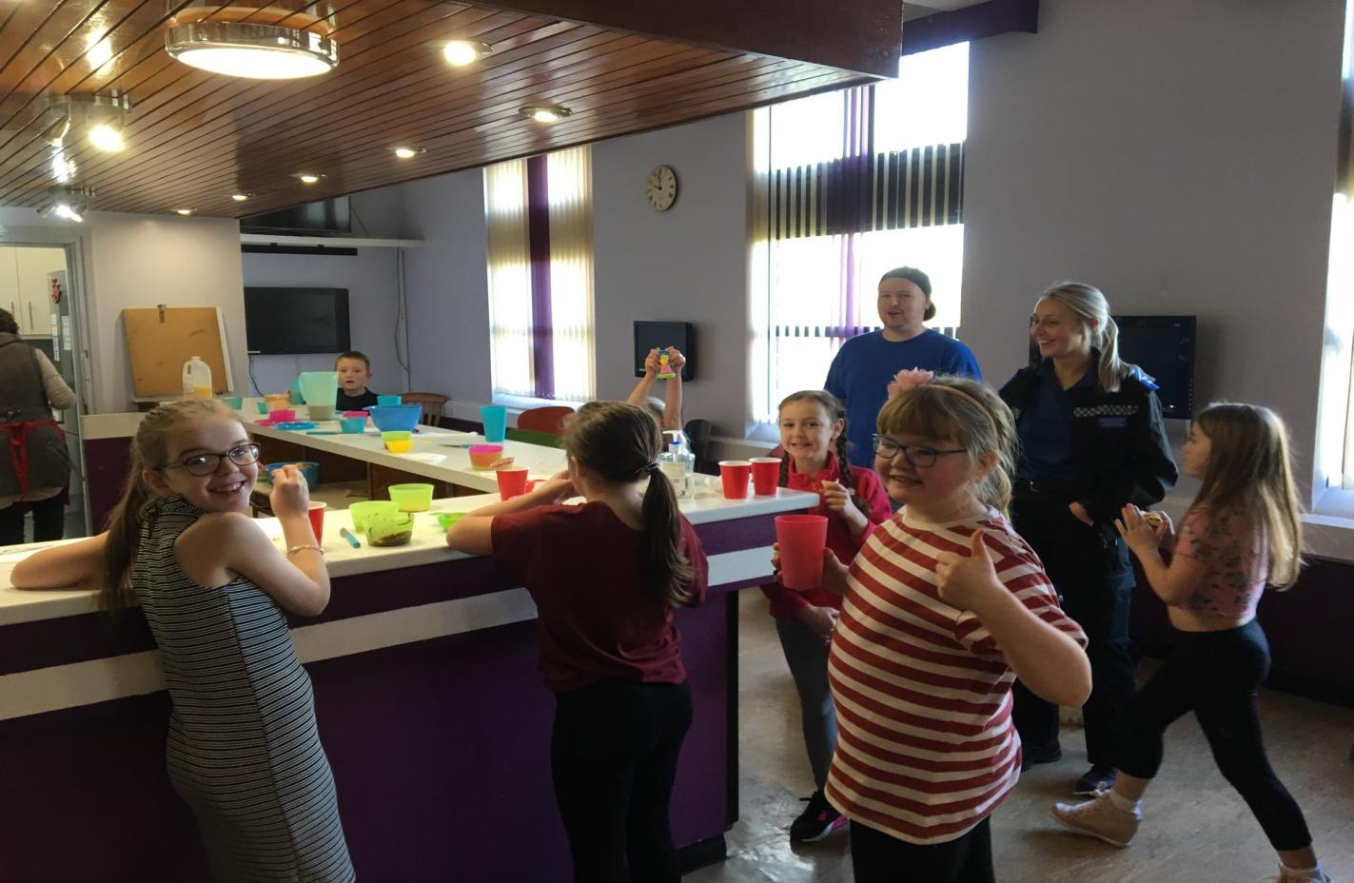

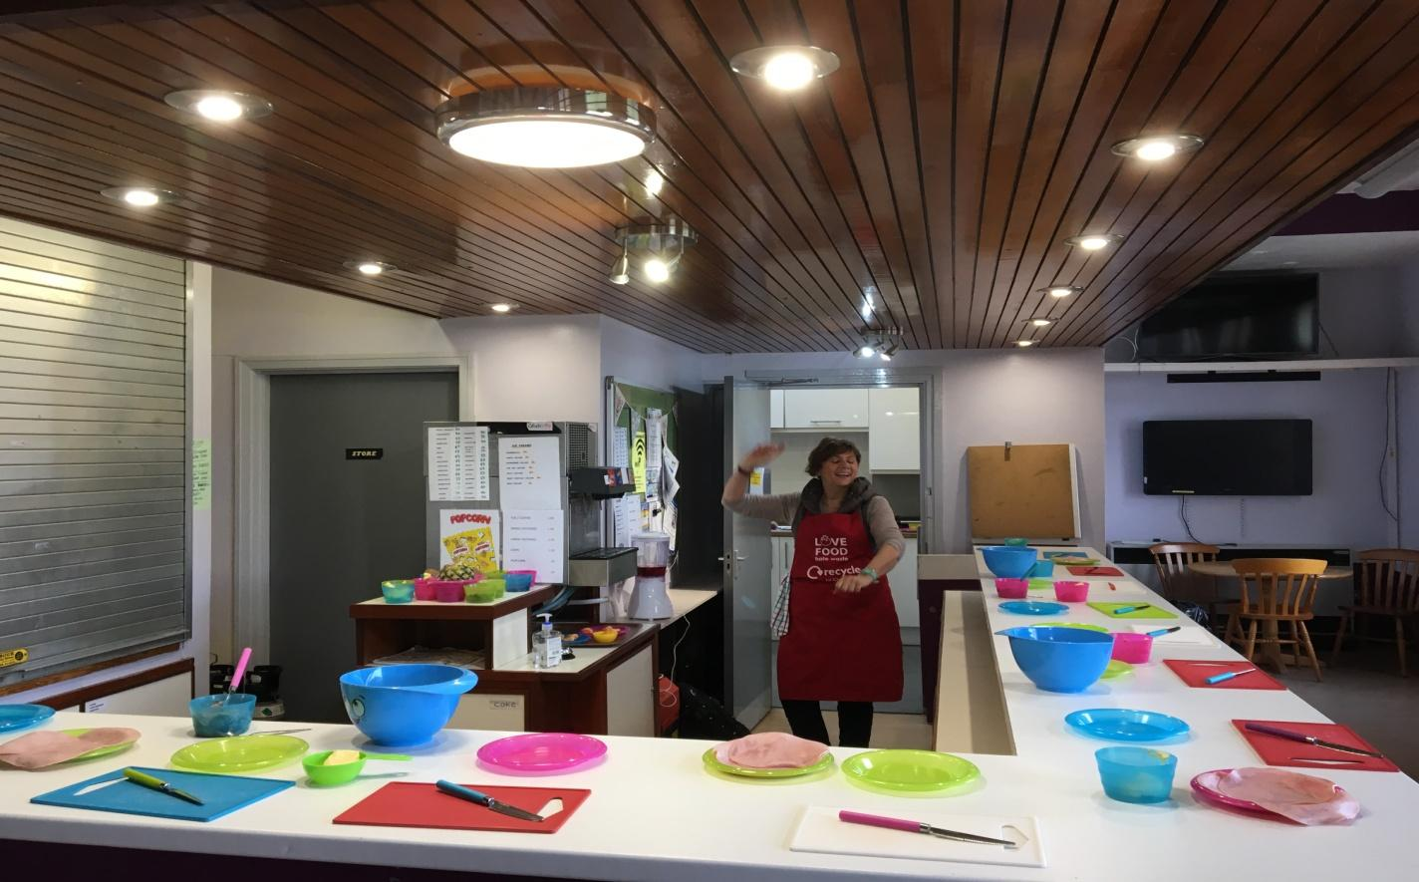

Introduction

Winsford Youth and Community Forum have been delivering Summer Play Schemes since 1989 in the Winsford area. This has been achieved with the support of its partners, Cheshire West and Town Councils, Cheshire Police and Fire & Rescue Services, Trusts, Foundations and local businesses. Winsford has an area of lower super output areas, where child poverty rates excess 50%. Children living on the most deprived areas of Winsford experience significantly worse outcomes related to health and education than children living in less deprived areas of West Cheshire. There is a distinct difference in health experience between those local areas, they are the most deprived areas in England.

There are few amenities in Winsford, and activities at the Leisure centre can be beyond the financial reach of some families. The Forum provides four Youth Clubs, in Wharton and New Images, two for 8 to 12 year olds and two for 12 to 16 year olds. The Forum has been successful in recruiting a Play Lead Coordinator, funded by the BBC Children in Need fund, to find funding to expand the Play Schemes to run in Half Term and Easter holidays.

The Play Schemes are structured to give the Children a range of different experiences and activities in an informal setting to enhance their skills, knowledge and understanding to grow as a person. The Schemes engage the children and young people and keep them off the street, where they may get involved with other young people that could be a bad influence on them. In particular, the Wharton estate is well known to Cheshire Police and has high rates of domestic abuse, anti-social behaviour, crime and drug dealing. We have evidence of a child as young as 8 years old being offered cannabis to smoke by older teenagers.

February Play Scheme

During the scheme the children enjoyed a range of activities that included learning to cook, sports, arts and crafts and creative drawing. There were also friendly competitions in drawing and pool, with a talent show at the end of the week. We also had workshops from local organisations, an art and crafts company and Animal Take Over, which gave the children the opportunity to find out about eight small animals which they could see close up and stroke.

Every child that accessed a provision was encouraged to be inclusive, cohesive, have fun and develop new skills. We provided a safe and secure environment for the children and because of out funding was free for all users. We targeted our advertising to the most deprived areas of Winsford, if we have funding for two sites, it will benefit a maximum of 52 children at each session, aged between 8 to 12 years old.
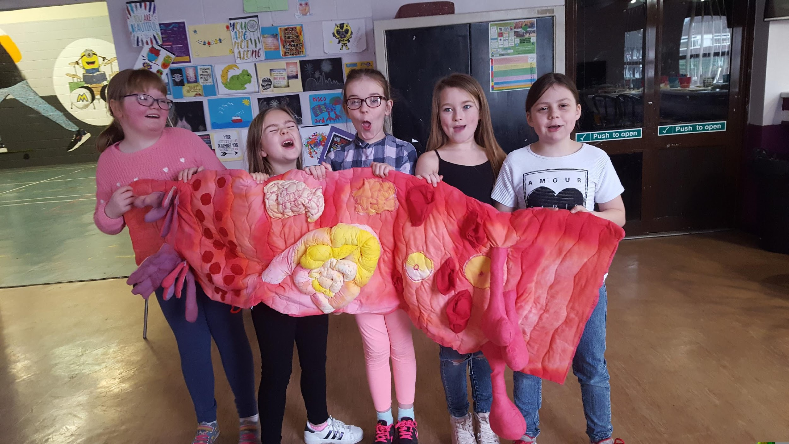
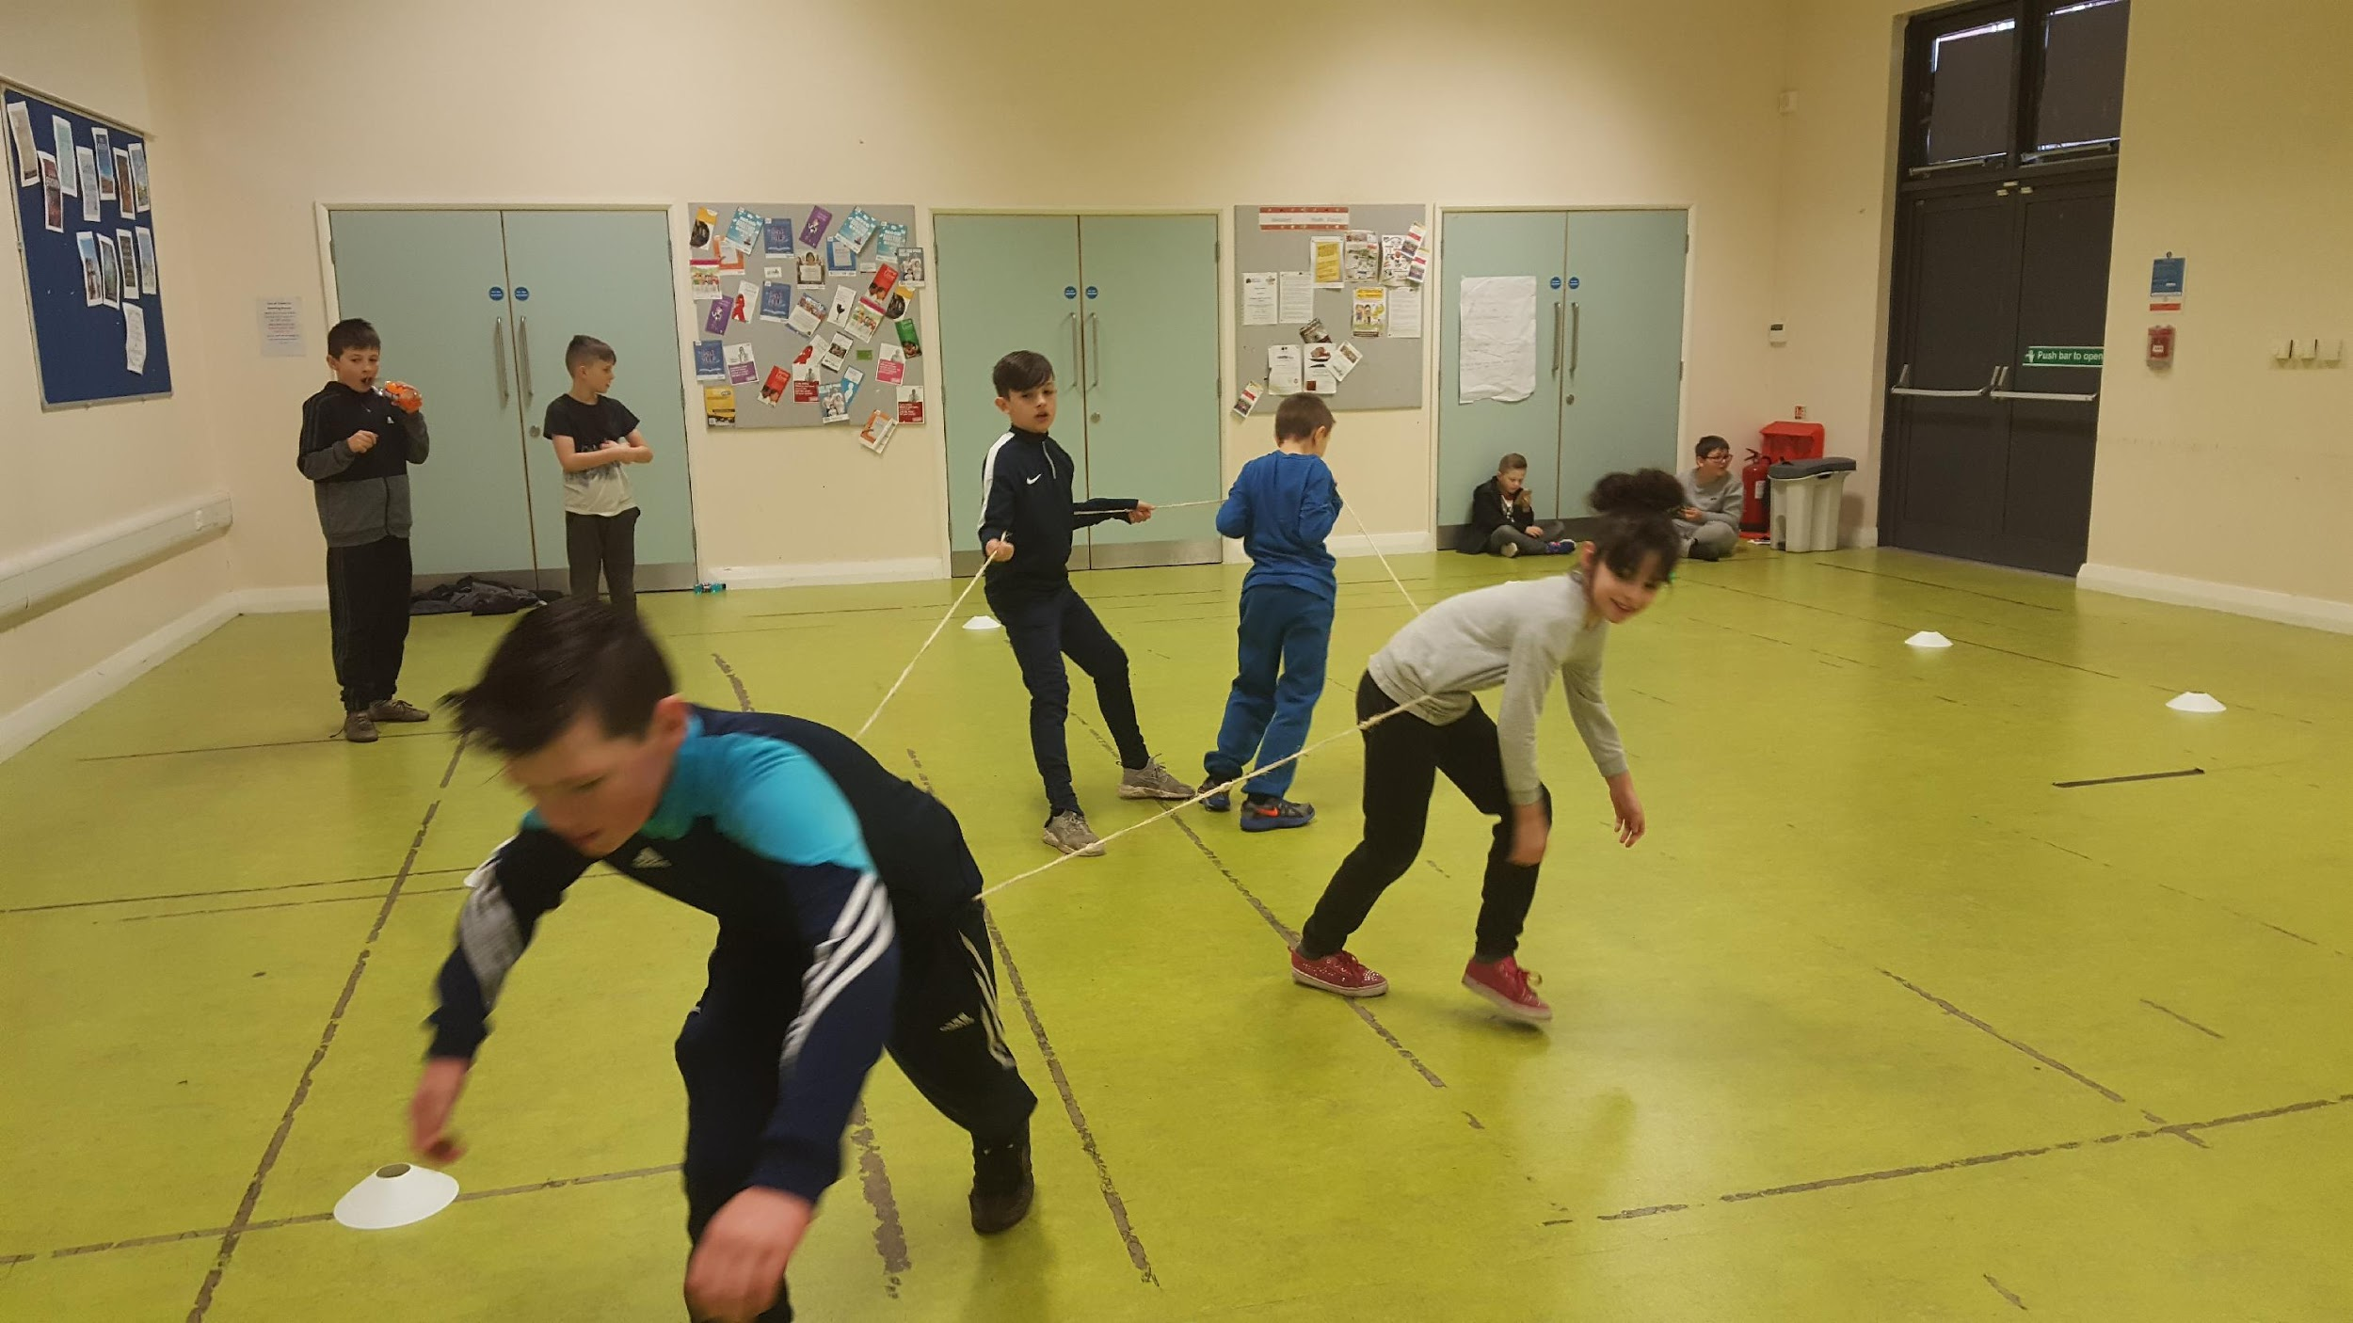

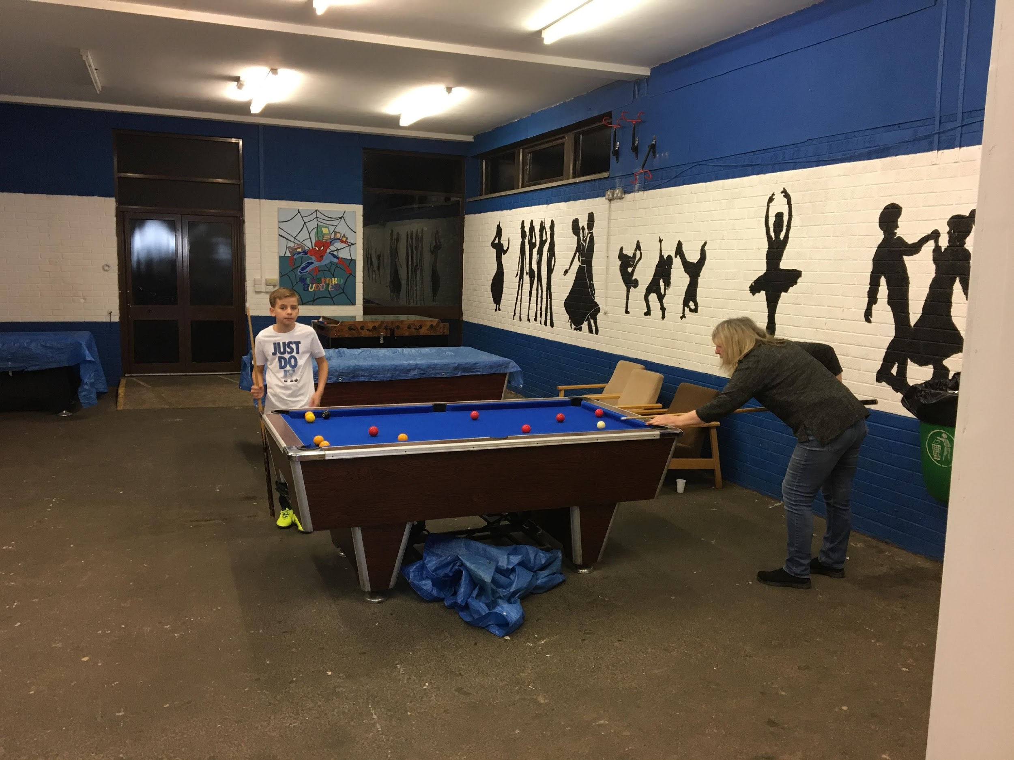
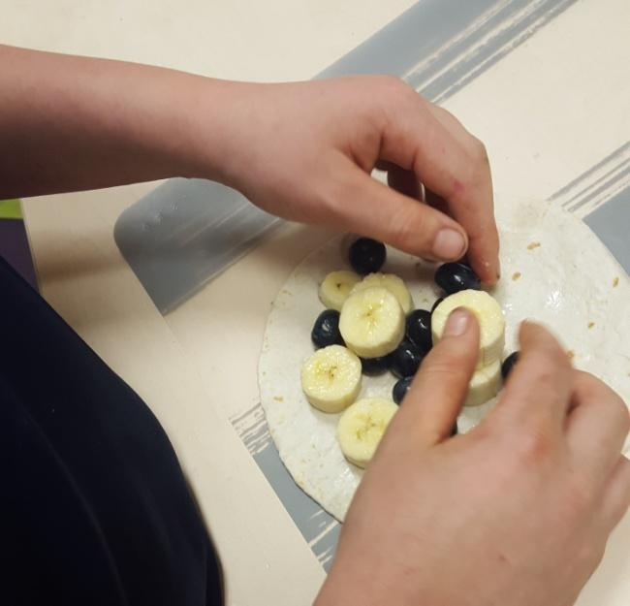

Outcomes
For the children to gain new skills, make friends and to have fun.
To encourage the children to participate and grow as a person.
To develop social skills through informal learning.
To build their self esteem and confidence as a result of the scheme.

Wharton

Through the Forums experience of running the youth clubs on this estate, it was realised that the children have a limited concentration span, therefore the timetable was very structured and in most cases each segment was between 30 minutes to an hour long. On average the number of children attending the Play Scheme was between 10 and 14 for each session. The feedback from the children was mostly good;

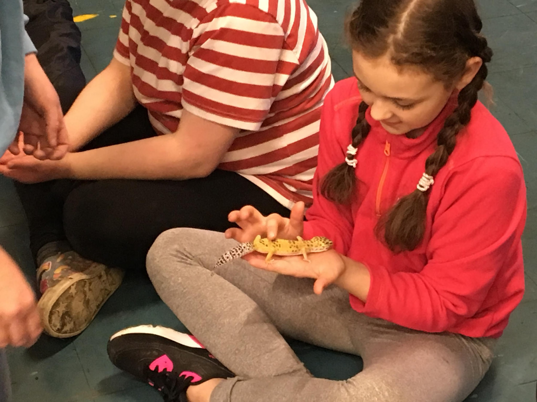
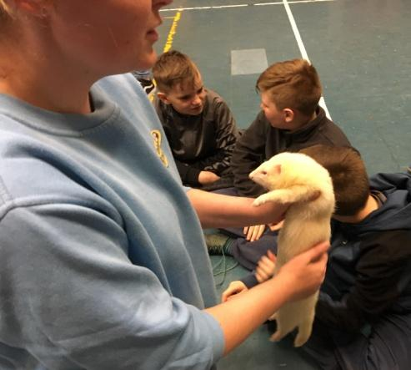
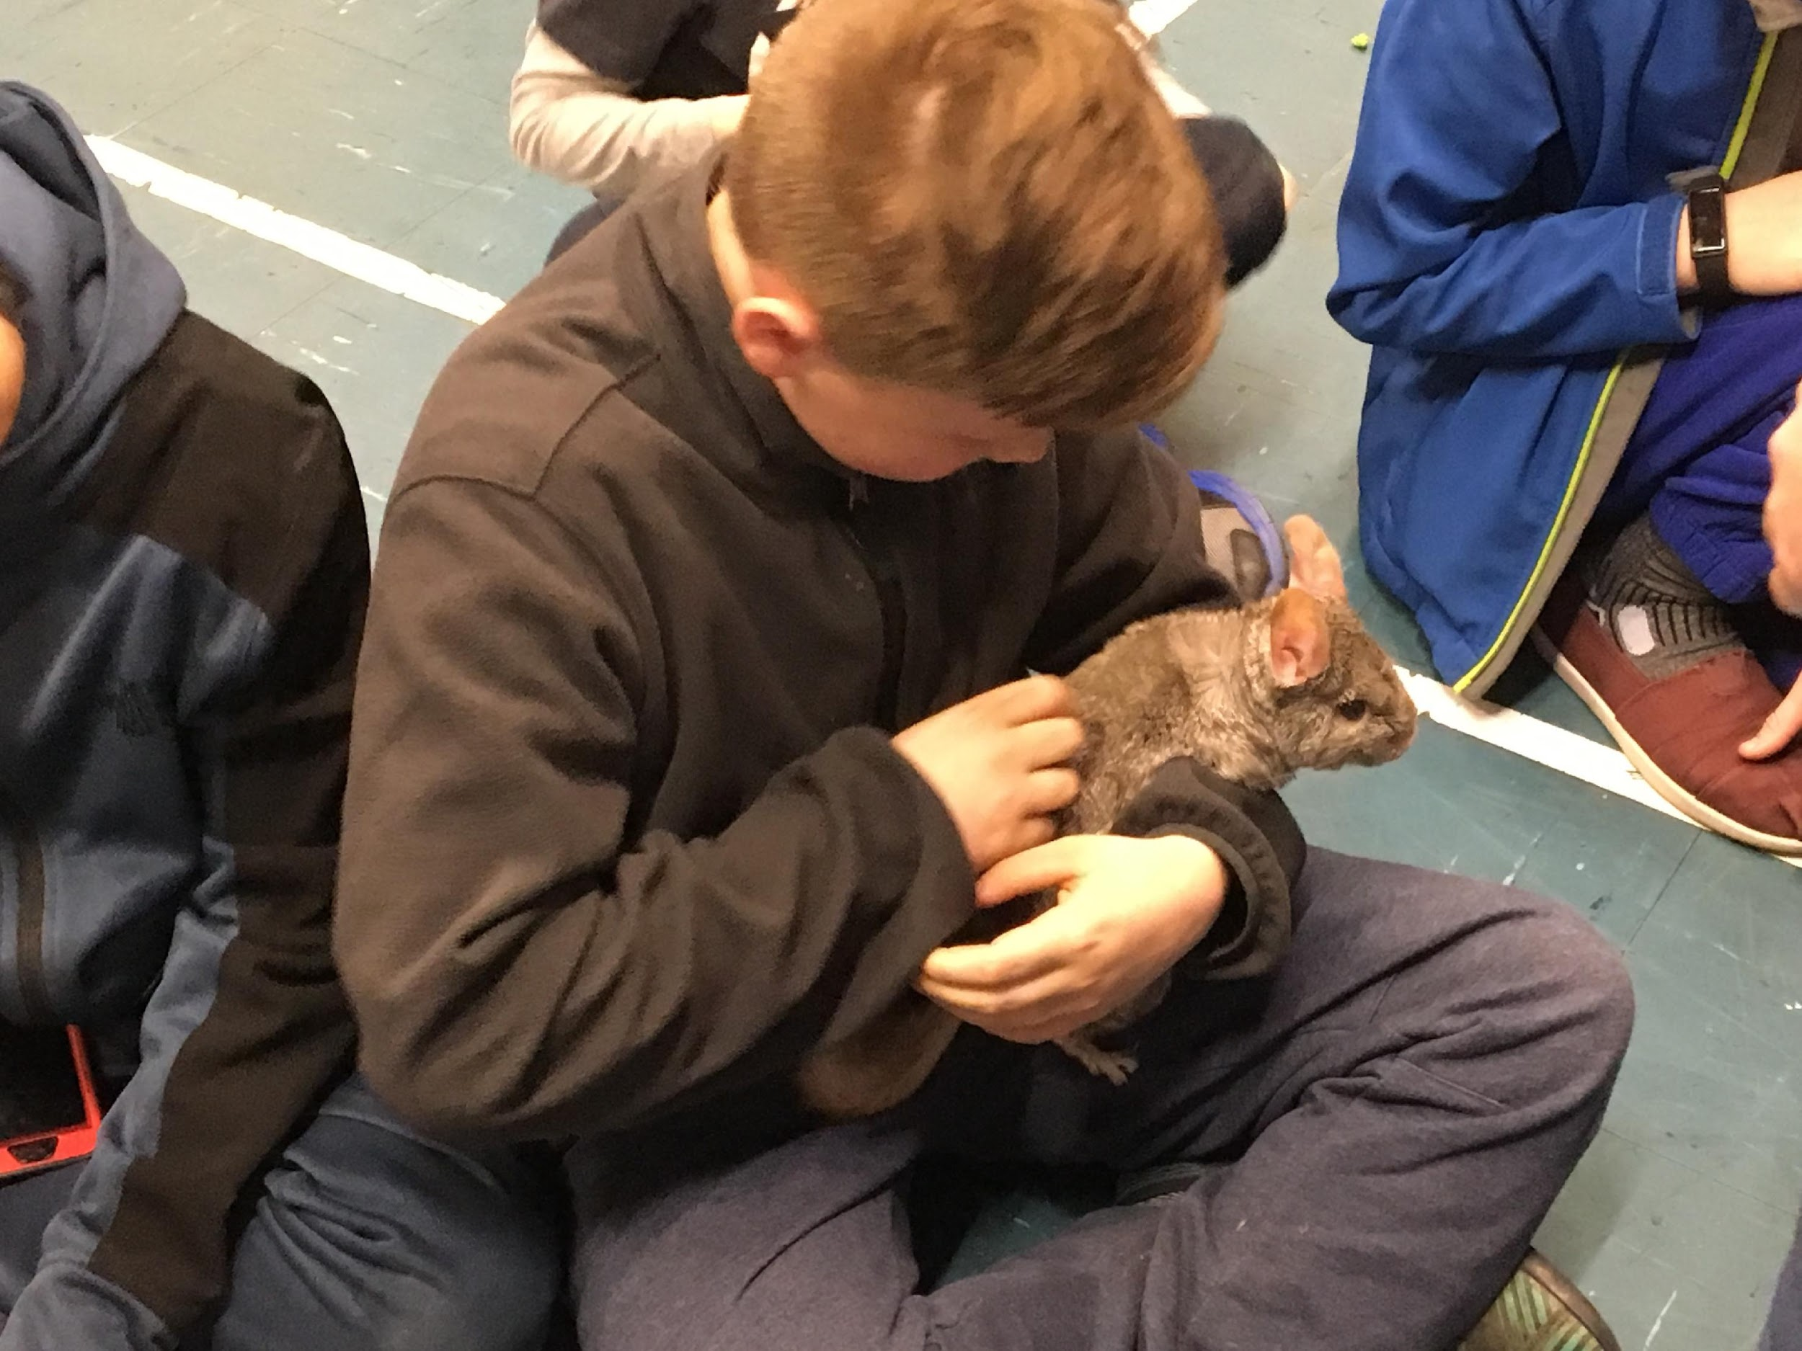
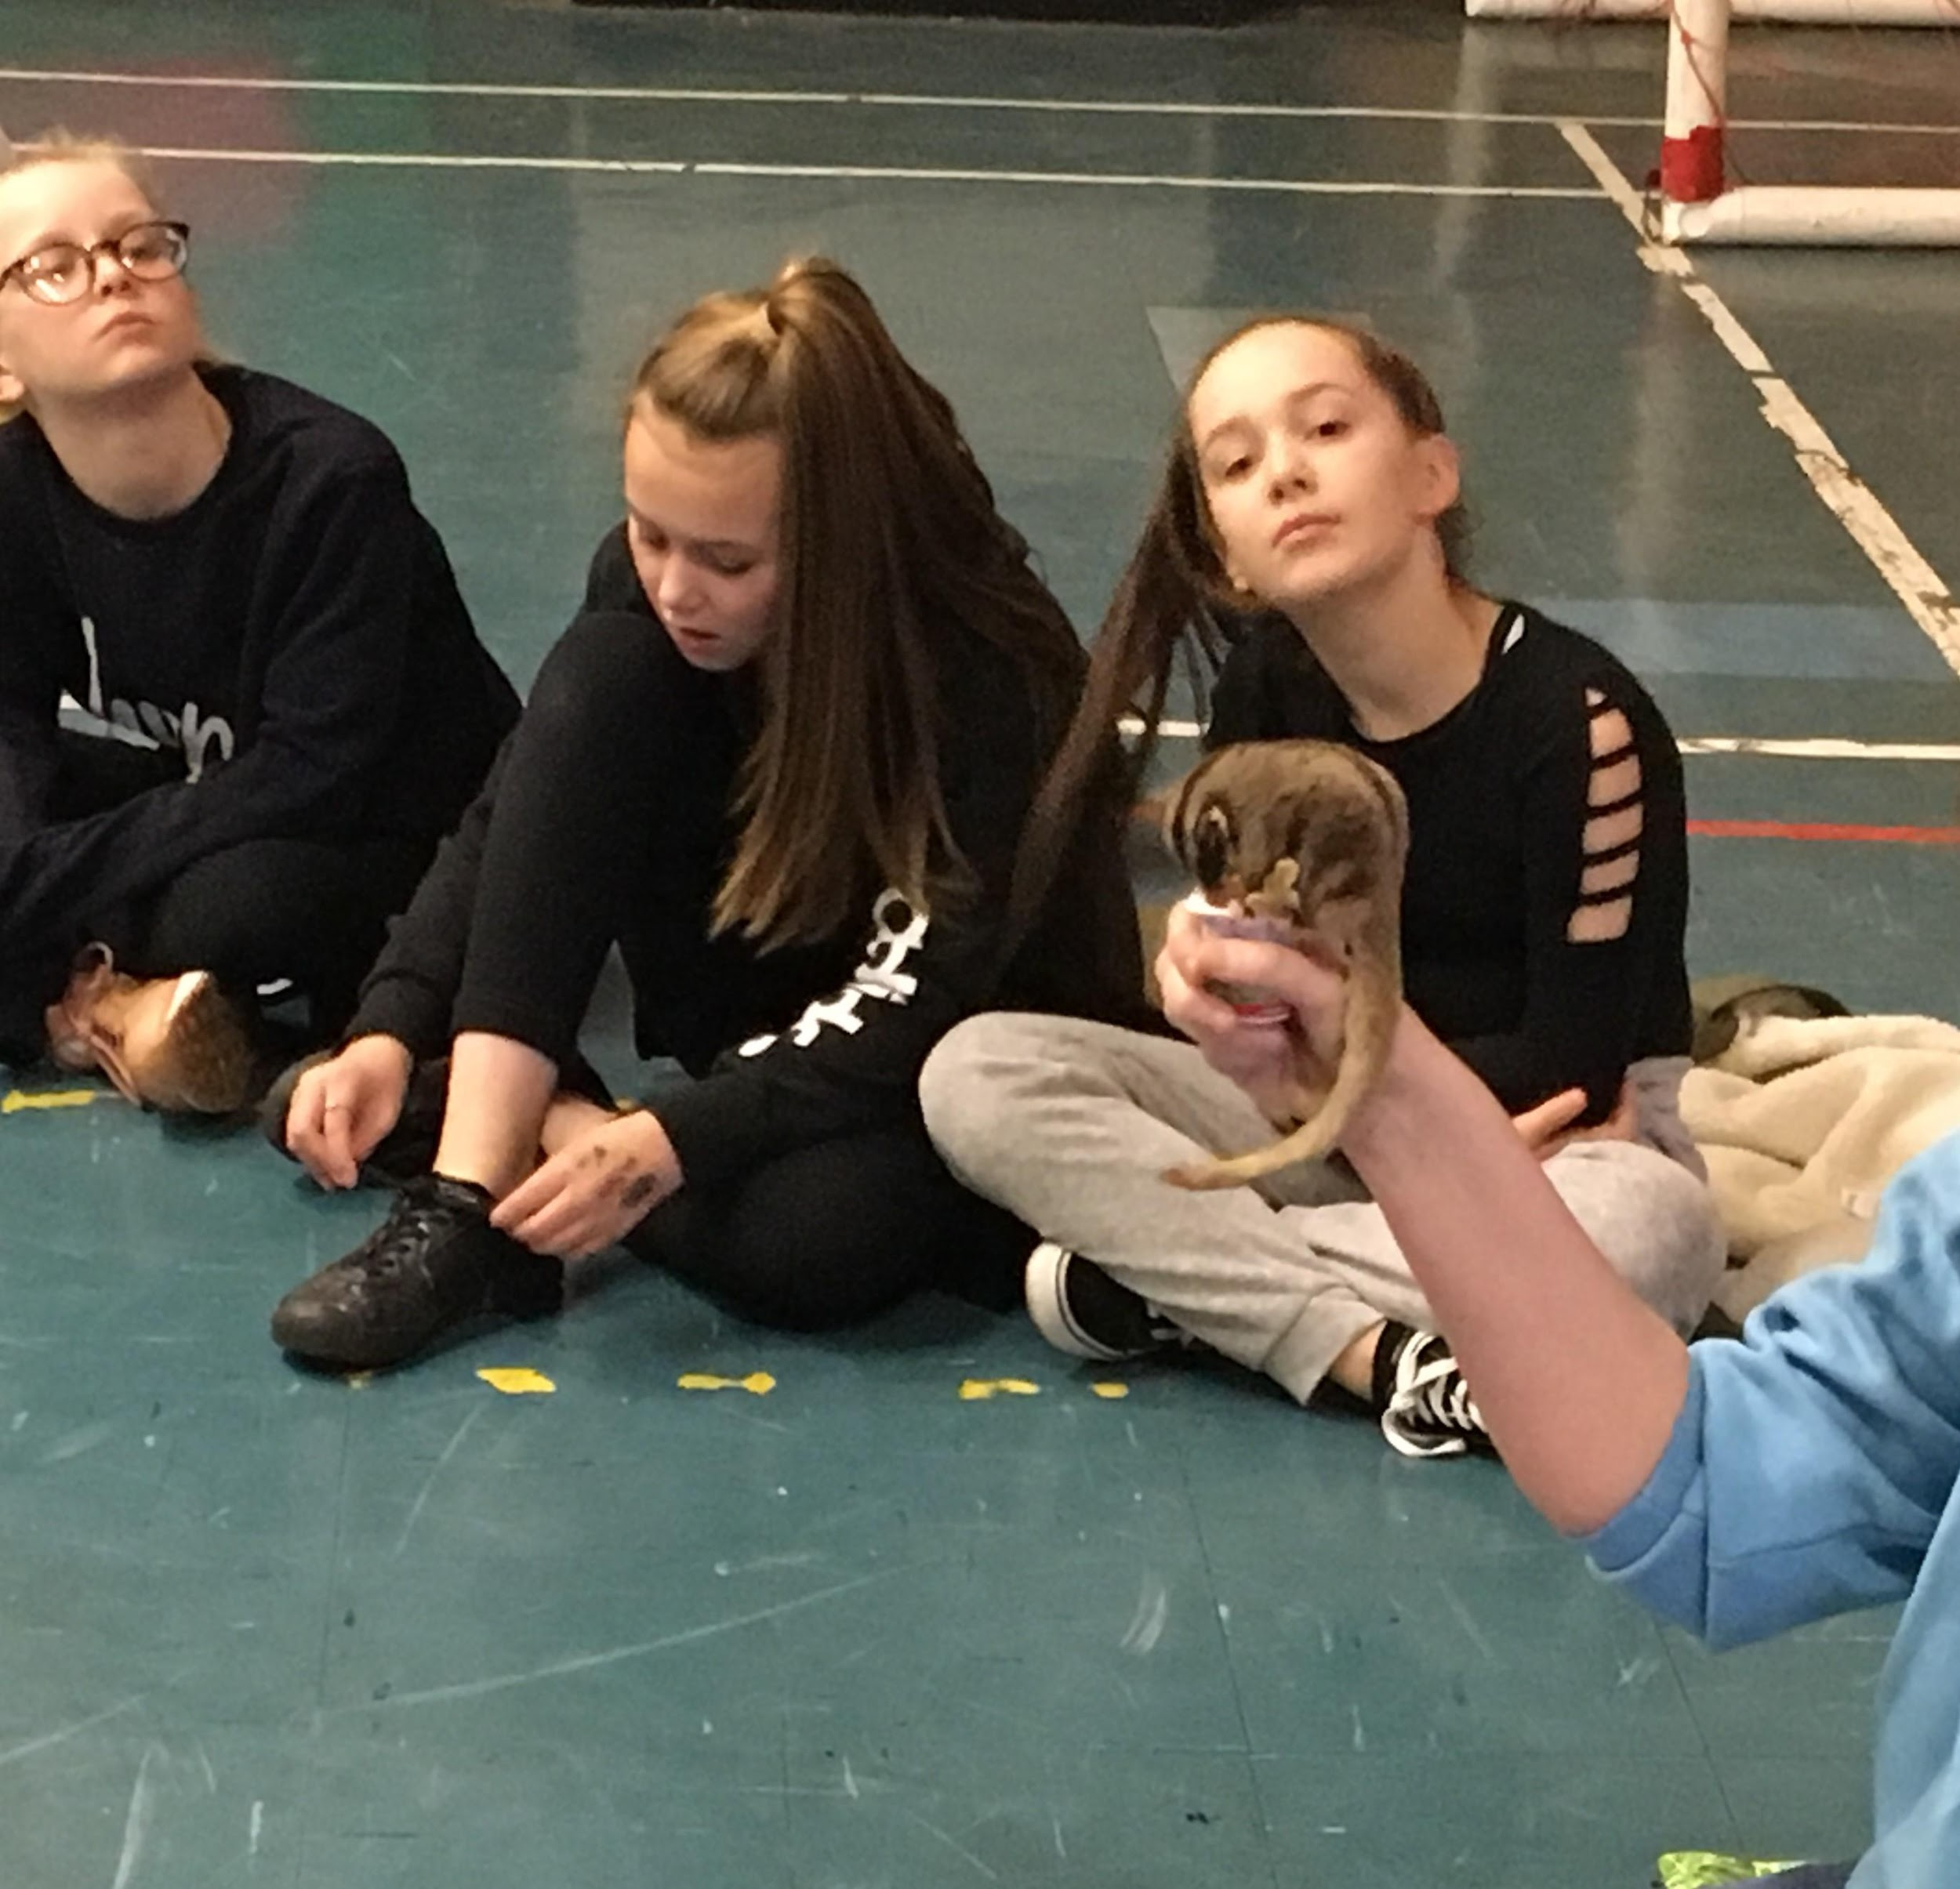

Feedback from Play Workers

The majority of the group engaged well and were willing to try the new workshops and the girls especially enjoyed making and colouring the fish for the ‘finding Nemo’ seascape. Six of the boys, with the most challenging behaviour, just wanted to play dodge ball, football and pool and were resistant to anything new that they had not tried before, but eventually did engage with support and encouragement. All the children said that the best session was the hour and half they spent with the animals.

The week was well planned in advance, we had a timetable that we mostly followed and new resources and crafts for the children to play with and make. The weather was too cold for canoeing and the rain stopped the treasure and scavenger hunts and any park visits. We must thank Chehsire Police for providing two Police Community Support Officers to help in both the Play Schemes throughout the week.

New Images

The young people engaged well on the whole, the girls particulally liked the cooking classes and the arts and crafts.The boys were more interested in the sports like football, basketball, dodgeball and pool.

The play leaders encouraged them to take part in all the actitivities, which they did. Overwhelmingly the children thought that the Take Over Animals workshop was the best session of the week. The local Police Community Support Officer was at the Play Scheme everyday and actively engaged with the young people and was a great asset to the team.

Feedback for external workshops

Fabfit was a thirty minute session with fun fitness for the young people, using hand/eye coordination.

NHS ran two sessions at each location, the first on healthy eating and they made healthy fruit wraps. The second session was a series of team games to build up trust and a team spirit.

Cross hatch provided an origami session at Wharton and made a number of different shapes, animals and a boat. In the second session there were two actitivites which the two group did alternately. The first was making faces out of vegetables and then modelling them in clay. The second was building paper straw towers.

Animal Take over: The children were introduced to eight animals ; a gheko, Hedgehog, Royal Python snake, A tree frog, a Chilean Rose Tarantula, sugar gliders, chinchilla and a Barn Owl. Not only did they find out about them, but they also had the opportunity to touch, stroke and, with the snake put it round their neck. 95% of the children said this was the best session for them.

Conclusion

This is the first time that the Forum has run a Feburay Play Scheme in Winsford, although we advertised the Scheme six weeks before the half term holiday the numbers were not as high as we had expected. We suggest an eight week advertisment for our next Play Scheme. The play scheme on the two sites did achieve our outcomes for the children to gain new skills, make friends and to have fun. Play Workers encouraged the children to participate and grow as individuals. The children did develop social skills through informal learning. This, in turn, let the young people increase their self esteem and confidence as a result of the scheme. The children at Wharton did need more support which was provided by the Play Lead coordinator and the Senior Youth Worker.

Feedback from partners, Play Workers, children, parents and staff was that it was an overwhelming success, so much so that Cheshire West Council have agreed to fund an Easter Play Scheme and we are in discussions with Cheshire Police and the Town Council to provide funding for the same at the New Images Youth Club.

Winsford Youth Forum would like to thank the funders of our February Scheme The Williams Family Foundation, that fund projects across Cheshire, Wrexham and parts of North Wales. The Foundation provides grants to local registered charities that are really making a difference to people's lives. They believe in funding individual projects to achieve their aim which is to help local charities to achieve their goals.

