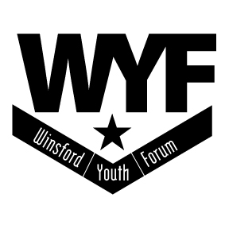

WinsfordYouth Forum
Annual Review 2015/16
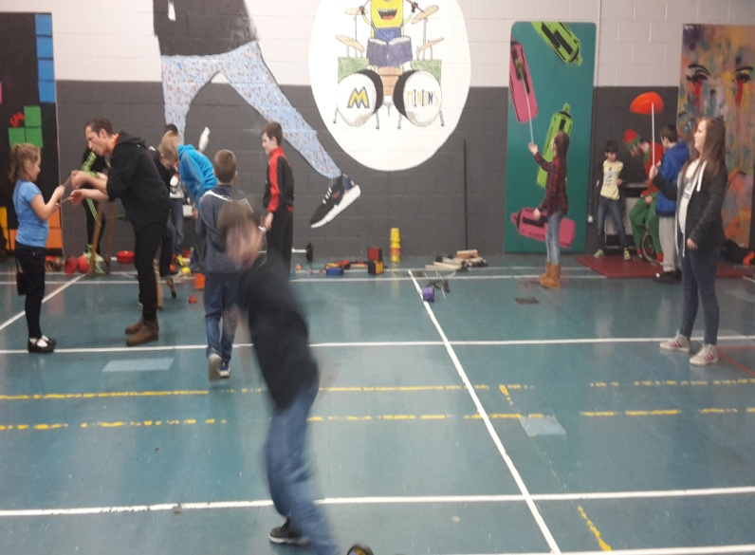

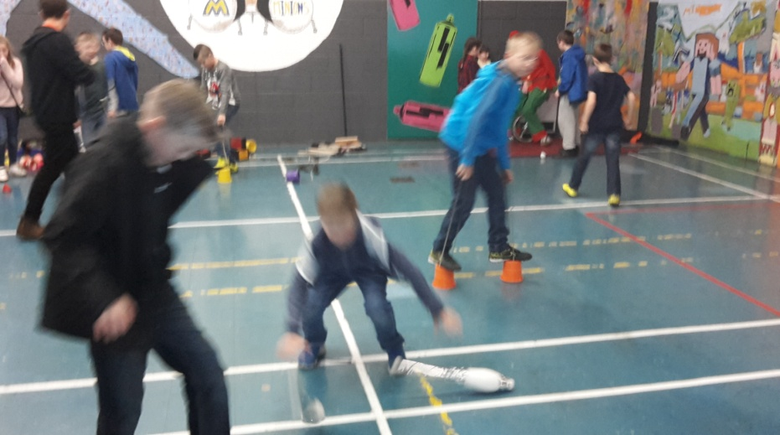

WINSFORD YOUTH FORUM Chair’s Report – 2015 – 2016
Winsford Youth Forum (WYF) has existed for over 30 years providing services to young
people in the community with the aim of enabling the development of young people
through various activities across the town. These are detailed in the body of this report.
In addition, WYF is providing activities for adults which are contributing to the social
fabric of the town itself.
It has been a privilege for me to chair this organisation over the past year and I thank all
those involved, particularly the Staff and Volunteers whose commitment and enthusiasm
continues to amaze. Also thanks go to my fellow Trustees and other Partners who
regularly attend meetings and other events despite their busy schedule.
I would also like to mention people in the local community who work with us to provide
and develop activities to meet their identified needs.
The groups who use the premises also contribute considerably to the running of the
organisation. Relationships with Cheshire West and Chester (CWAC), Winsford Town
Council and Weaver Vale Housing Trust are good and hold well for the future. The year
has been hard at times but the future is becoming brighter! Funding opportunities have
arisen during the year that are rarely missed by staff and, although not always successful,
have resulted in continued development in line with our aims. WYF is an integral part of
the town we live in. Many adults who are now parents (and even grand-parents)
remember well when they were younger and attended the Junior Club! I now look
forward to the future with optimism and excitement as developments in the coming year, particularly with Information Technology and Social Networking, offer opportunities
to both young people and adults.
Alan Badder –
Chair

Annual Review 2015 – 2016

The Trustees of Winsford Youth Forum present the Annual Report for the year 2015 –
2016,which includes our charitable status, support and work with other organisations
general review, base reports and our aims for the 2016 - 2017
The Financial Report will be presented as a separate document

Winsford Youth Forum`s Charitable Objectives

1. W.Y.Forum is a registered charity working with and on behalf of children and young
people throughout Winsford and the surrounding area, by providing activities, facilities
and services for children and young people aged 8 – 25, and to assist them, later as
parents via community interaction, by working in partnership with other organisations
and agencies

2. To promote and organise co-operation in the achievement of the above
purposes and to that end bring together in Council representatives of the
voluntary organisations and statutory authorities within the area of benefit.

Winsford Youth Forum is a registered charity and a company limited by guarantee.
It was established in 1981 and incorporated in 1986. This is our 34th Report.

W.Y.Forum still acknowledges the `Every Child Matters` framework and uses the 5 outcomes of being healthy, staying safe, enjoying and achieving, making a positive contribution and achieving economic well being, throughout its work with young people, and now the whole community.
Trustees for the year
Chair – Mr A Badder
V.Chair – Cllr M.Kennedy
C.Secretary – Mr G.Bell
Treasurer / Acting Coordinator – Mr B.Barton
Cllr P.Booher
Mr S.Doyle

Cllr T.Blackmore resigned as a Trustee at the A.G.M, to support the restructuring.

FUNDERS and SUPPORTERS
Funders for this year included
Cheshire West and Chester Council,
Individual CWAC Councillors,
Winsford Town Council,
Weaver Vale Houseing Trust,
Asda,
Active Cheshire,
Vale Royal Kitchen`s
Roberts Bakery,
Comic Relief
Old Star ( E.Walsh )
Cheshire Police Commissioners Support Fund

Supporters for the year included
Jon Sandford ( Cranfield Trust ) for leading on a number of `Governance` workshops, resulting in operational changes.
Continual support from the Youth Federation
Probation Service `Community Payback Team` by helping with the refurb work at New Images.
This year we held our first `Open Day` which involved help and support given by
numerous volunteers and members of the community.
Finally, a big thank you to our staff for all their hard work and additional support, which
As usual goes far beyond their respective roles.
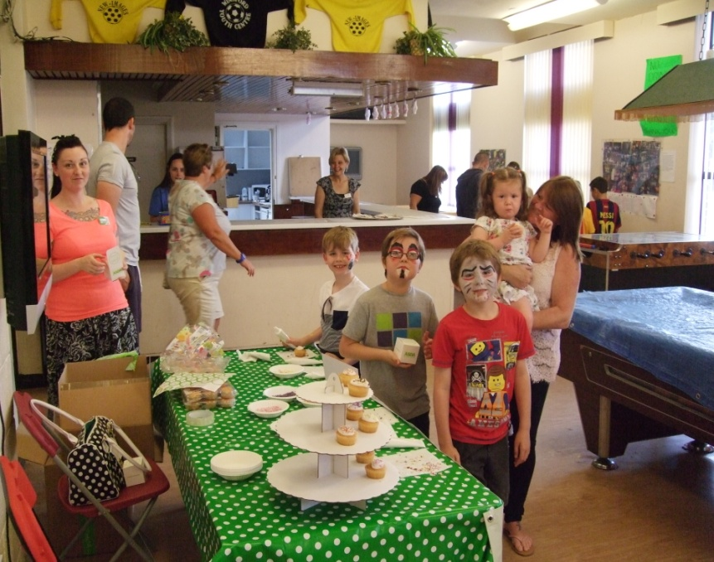

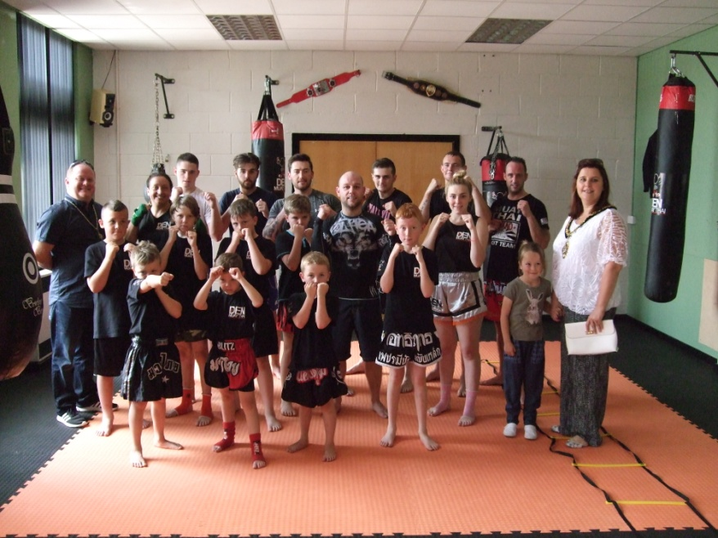

New Images Open Day 2015

PARTNERSHIP / COMMUNITY PROJECTS
We attended numerous partnership meetings throughout the year, all linked
To our delivery, and our aims/objectives. These included GGO Project event,
D Fest, Wharton Bonfire Initiative, Smoothie/Pizza events, Playschemes and Wharton Fun Day
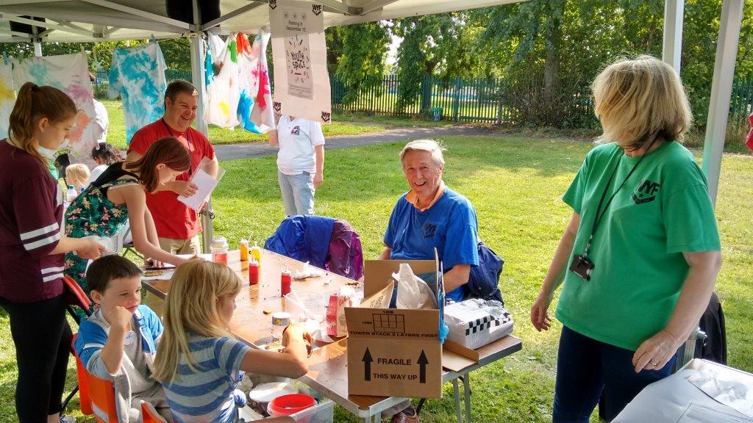
August 2015 G.G.Funday

OVERVIEW – of the year

From May to the end of July our focus was on securing a second year at New Images. That required an inspection and a verbal agreement that we could continue until further notice. Local CWAC Officers, those that have the relevant responsibilities, have always been supportive within their respective Roles - so with that good news we decided to celebrate and have an `Open Day` to share our news with the community. That took place on the 1st August and involved every user group, member of staff and volunteer we could find!
Several external activities were hired in to make it a memorable day. We had several key targets for the day including sharing with the community our refurbishment work. Promoting the centre was key, along with gathering interest from those who would be prepared to become a Trustee. This was one of our `targets` as set out in last years report, one determined by a thorough Governance Review we undertook throughout the year. We were successful in that process, but still need to enhance our Trustees with those with particular skills, so this remains an ongoing aim.

Our second aim was to develop our partnership working – which we have done, via Active Cheshire`s involvement and financial support, local business, via Vale Royal Kitchens who funded a complete new kitchen, and by WYF now attending the `Children`s Advisory Board`.
Securing and lengthening our Licence/Lease continues to be our primary aim and with our move into a third year, progress appears to be moving forward with that target. To date we have not been able to complete our fourth and final aim from last year – a new Business Plan, due mainly to the ongoing uncertainty of the future of youth provision in Cheshire West and our role, if any, during this period of continual change.

Nevertheless youth work did continue here throughout the year for the over 12`s, and we now know we will stay until 2018, providing there is a need! Meanwhile refurbishment work continued at New Images. Along with a new kitchen, we totally refurbished the male toilets, funded by Active Cheshire, and soundproofed two rooms as a commitment to future work with live music delivery.

CWAC`s support was also highlighted during the year with the funding of the 5 year electrical test which has highlighted numerous issues, many expected, some not, all requiring expenditure, which we have to meet by the end of this financial year.

Shortly after the Open Day, we had a request to host an American Wrestling Group – who now have weekly training sessions and host monthly Wrestling shows, something entirely new and different. This variety in delivery extended into February when we responded to a request by Bentley`s of Crewe to host an event targeting youngsters who have an interest, in a career in the car industry. One day is not the same as any other when working in such a centre, opportunities arise in all directions, showing the value of such a centre to the community.

Sadly though, the year did see some downturns in opportunities. Around xmas we heard that changes were to be made to the ownership of the Marina. This was confirmed by February, when we were told that ownership had been passed back to CWAC and that use would be suspended until further notice.

Consequently this has been a summer without any canoeing-kayaking, and to date the situation remains unresolved

Work however, has continued at Wharton Community Library, with youth provision on Thursday and Friday and Wharton Youth Centre, although reduced due to funding and changes in operational delivery. It was another busy year, one fully supported by an understanding staff team, who remain committed to our future and the future of young people throughout the town.

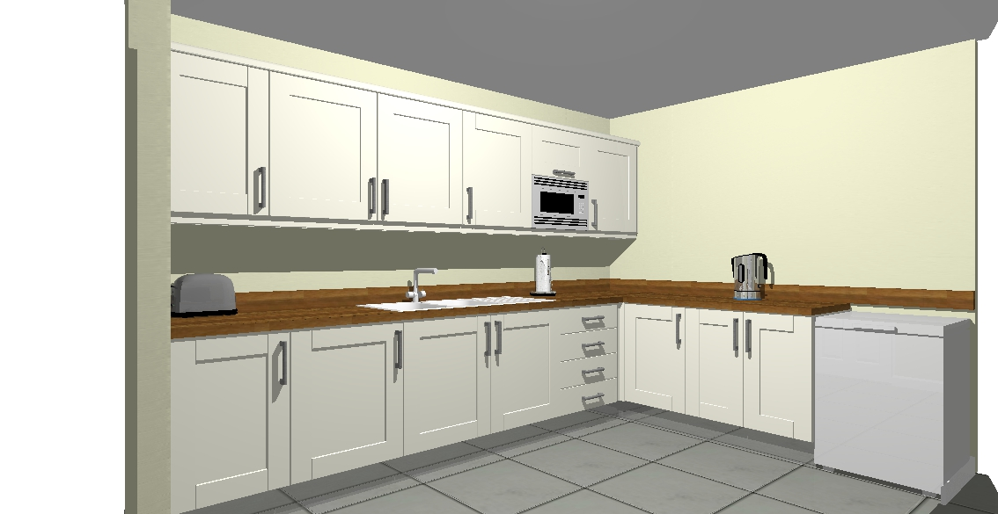

Thank you to Vale Royal Kitchens for the New kitchen
supplied and fitted in September 2015

Wharton Community Library
Junior Club – opened every Thursday for the 8-11 year olds, (except August )
with continual funding from Weaver Vale Housing Trust. Targeted work via activities, especially arts/crafts was aimed around environmental issues, responsible behaviour, dangers of fireworks and illegal fires. This was achieved via the Fire Service led `Bonfire Initiative` (multi agency project) and respect for others.
Forty sessions delivered with 610 attendees – some of those made comments. Mia,
Sophie, Kate, Ellan who all thought `it was fun, and you can make lots of new friends`.
Cadey liked the club because she `likes to draw and play dodgeball`. Two more liked
playing with their friends after school – made them feel comfortable! Playing games is
a big feature of the club

Senior Club – On Friday nights, continued initially via funding from Weaver
Vale Housing Trust, until Cheshire West and Chester funding was secured. The summer was relatively quiet, due to the sudden involvement of many of our youngsters playing football on the park – against adults! This became a regular occurrence, which we supported with equipment and a football kit. Attendances remained quiet throughout the autumn, with those attending stating that they preferred Wharton Y.C as a venue. So in November we responded to their stated needs and moved to Wharton Y.C. However
after 6 weeks there was no was no improvement, so in the new year, we moved back.
to the Library Forty sessions delivered with 222 attendees.

We continue to attend Wharton Community Library user group meetings,
after school `smoothie/pizza` events, were delivered and in 2015 supported the Wharton Funday event.

Marina
New season here commenced end of April, with more attendees than usual, but this was not sustained. Attendances remained lower than usual through-out the summer, with a drop, also in external user group use. Two of our home grown instructors went off to University in September 2015, so we had to recruit a new support instructor, who brought along additional skills via Paddle boarding. Unfortunately we could not get any additional funding to develop this sport! Funding though, for the canoeing/kayaking was obtained. Once again through CWAC Members Budgets
In the new year we heard that the `Owners` of the Marina had relinquished their use of the Marina and returned their agreement back to CWAC. They in turn have stopped any use until further notice. Fortunately this occurred during our `closed` period for these activities.

Wharton Youth Centre ( Greville Drive )

Openings here for seniors continued on Mondays with CWAC Youth Service
delivery, we delivered Thursday night provision courtesy of funding from the Police Commissioners Fund – which lasted until November, and with CWAC funding, supporting through to April. Regular group of y.p attended right through the summer – 116
over 17 sessions, but then from September, staff were resorted to doing detached
work due to the lack of interest. It was a summer when many of these youngsters
became totally immersed in football. By playing most nights against the local East
Timoians, who themselves were organisied into teams. Our staff team supported this
`bonding` by helping to supply kit and the required equipment.

Action For Leisure -This is a social club for adults with Special Needs, with support from numerous `carers`, which continued throughout the year, with regular attendees and a high volume of visitors. This year a new Vol support worker has joined making an instant impact. Club averages 18 – 20 per week, many with their carers.
The Princes Trust `Team` Projects, led by Cheshire Fire and Rescue Service have had three, 12 week `Teams` over the year, targeting those not in Full Time Education, Work or Training, Sessions held during the day.

Bonfire Initiative - Fire and Rescue Service led project. Culminating in a Community Bonfire at the centre. This year attendances were manageable, due to lessons learnt from the previous year. A very good event – although lighting a big bonfire after a heavy downpour took some time and skill!!

Playscheme – Annual user of the centre for its four week programme, for those
Six – eleven years old, during the summer school `hols`.

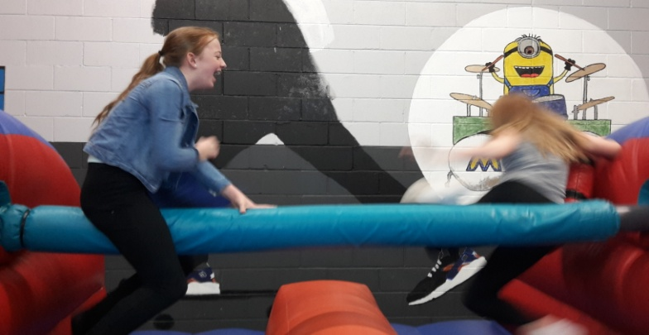

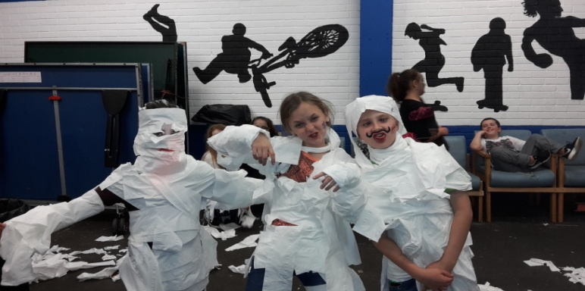
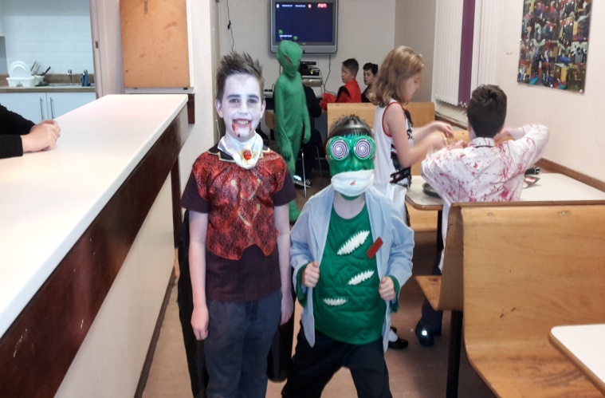

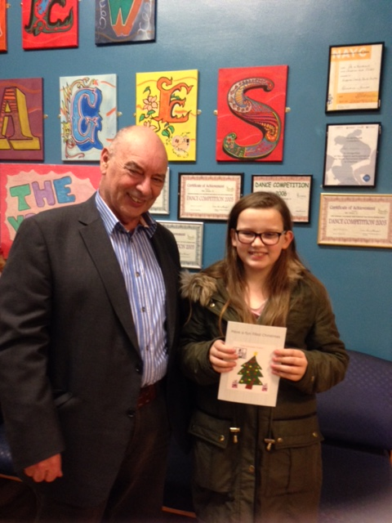

Winner of the 2015 Christmas Card Competition, Ellie Lovelady

New Images
This is the second year of our management and refurbishment of this Centre. Refurbishment work continued primarily through the input of the `Community Payback Team`(CPT) Two key areas completed. The kitchen was completely refitted by `Vale Royal Kitchens` - with decorating and tiling completed by the CPT. `Active Cheshire` funded work in the boys toilets, which included a total tiling operation and new toilet cubicle, all undertaken by CPT. Sound-proofing and decorating was also completed in the boys showers, now making this a usable additional room for music. Some external paintwork and repairs around the roof were completed, and work on the girls toilet started – all to be completed. Meanwhile CWAC organised in late March the 5 year Electrical Test.

User Groups – Last summer we welcomed an `American Wrestling` organisation to the centre. They meet/train here every Sunday from 11 -4.30pm and present a `Show` most months, which are now a regular attraction. These are now our third major users alongside the Kick Boxing and Mixed Martial Arts (MMA)Groups. Other `users include the `Bands`, Zumba, CWAC Meadow Bank Lodge and the Playschemes

Meanwhile we continue to operate youth provision on these nights –
Tuesday (Seniors) operated by CWAC
Thursday (Buddies S/N Group) operated by CWAC
Fridays - Our Junior club, funded by Winsford Town Council, which since xmas
has seen a huge rise in its popularity. To support this we have a team 4 staff and 4 vol`s
delivering a regular mix of activities, arts/craft and `special` seasonal fun nights.
Forty five sessions delivered with 3164 attendees. Feedback from Ben, `who wished it could be every day`, from Kelyn ` who said `I get to stay up to 9.30. From Amelia and Evie,
Who could meet and play with their friends. Ebony, Ellie, Harvey and Leah are happy
`being able to play somewhere when its cold and dark`. Alancia and Finley found ` so much to do and lots of open doors to do new things and make new friends.
Saturdays (Seniors) funded by CWAC, but run by WYF Disjointed year due to the irregular
funding. Attendances averaged 18 per session. Y.Peoples comments include ` its
something to do and never gets boring` `it`s fun and better than sitting at home` and
importantly to many its about being able to make friends, and enjoying themselves

After School Club – operated for most of the year, funded by CWAC, on two days per
week, with limited success. However we were able to link in with Bentley`s of Crewe,
who are the primary sponsor of a new UTC School opening in September wanted to do a presentation to youngsters from the Academy. This, in partnership with the Academy was achieved on 19th January, when 23 youngsters attended and engaged with the presenters – plus shown a Bentley car parked outside, to the front of the centre !

MOVING FORWARD – major aims/targets for 2016/17

- Continue strengthening the Board of Trustees
- Rewrite our Business Plan
(Pre requisite for extending and securing long term Lease/Licence )
- Formulate policies/strategies around delivery of music making, school
Holiday activities, special need provision
- Target daytime use- extend work into adult provision
- Develop `Healthy` Coffee. Bar facility

