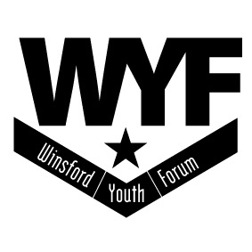
Winsford Youth Forum
Annual Review 2013-14
Collated by Bob Barton

President: His Grace the Duke of Westminster, OBE.TD.DL
Winsford Youth Forum is a Registered Charity (517406) Company Limited by Guarantee (1976247)

Chairs Foreword – Cllr P. Booher
Once again I am able to present to you another annual report, reflecting the work by our staff and the involvement of young people within our youth clubs and various other venues. I was shocked during this year, to hear of the closure of The Edge, which throughout its years, under other names, but run by WINCAP, served not only the Over area, but like us, operated and was involved throughout the town, for at least 25 years. To loose a major contributor to the social fabric of Winsford is devastating,and is a timely reminder to how fragile a Voluntary Organisation can be. As a Trustee, I and my colleagues have a duty to ensure that we, W.Y.Forum operates within a Legal framework, have the relevant policies and practices to deliver our aims and objectives and operate within our financial means with sound financial scrutiny.
I am thankful that we manage to continue that, as our accounts and this report will show. Ever year is hard, especially obtaining funding and maintaining services. This year was no exception and once again I need to thank all of our funders and supporters for that – for the future still remains uncertain, in a still changing environment, when working with young people. Those Funders remain as being Cheshire West and Chester Council, Winsford Town Council, individual Councillors, Weaver Vale Housing Trust, Sport England and especially this year, another Trustee Cllr M.Kennedy who as Mayor made W.Y.F one of his Charities, to support.
This was the year that our Community Organiser became a mother, that the work to save New Images continued and CWAC`s vision for the `youth service` became apparent.
The Trustees and I would like to thank all of our supporters, our volunteers and all of the staff for their continual commitment and dedication over the year, to making this yet another successful and positive year – helping to meet the needs of young people from Winsford.
Chair/Trustee
Cllr P.Booher

WINSFORD YOUTH FORUM - Annual Review 2013 - 2014

The Trustees of Winsford Youth Forum present the annual report for the
Year 2013 – 2014, which includes, our charitable objectives, support for
Other organisations, partnership working, our aims for the following year
And base reports. The Financial report will be presented as a separate
Document.

Winsford Youth Forum Charitable Objectives

1. Winsford Youth Forum is a registered charity working with and on behalf
Of children and young people throughout Winsford, by providing activities,
Facilities and services for children and young people aged 8 – 25 often by
Working in partnership with other organisations or agencies.

2. To promote and organise co-operation in the achievement of the above
Purposes and to that end bring together in Council representatives of the
Voluntary organisations and statutory authorities within the area of
Benefit.
Winsford Youth Forum is a registered charity and a company limited by
Guarantee. It was established in 1981 and incorporated in 1986. This is
Our 32nd Annual Report.
Winsford Youth Forum still acknowledges the `Every Child Matters` framework
And uses the five outcomes of being healthy, staying safe, enjoying and achieving, making a positive contribution and achieving economic well being,
Throughout its work, with young people.

Trustees for the year –
Chair - Cllr Pam Booher
V.Chair - Cllr Mike Kennedy
Company Secretary - Cllr Tom Blackmore
Acting Coordinator - B.Barton

Overview of the Year

The year started with breaking news that the Academy were seeking from
CWAC an extension to their `Licence` agreement – so that the `Unit` could
remain separate from the school, while the main school adjusted to the
new building. Consequently our own un-submitted plan to take over the building was deferred, along with alternative arrangements to relocate the
office, should that be necessary. We eventually heard that that extension
request, and our use of the centre had been agreed. So it was with great
relief that we could continue, and to have additional time to put in place
a detailed `Community Asset Transfer` bid, submitted in November.

Meanwhile CWAC Review and implementation of their Youth Service
Delivery, for the future continued, which gave us another year on our
existing S.L.A – running Friday/Saturday night provision at Over and
Wharton.
Then in November, one morning, we receive a telephone call from The
Edge, stating that all provision is cancelled until further notice !
Days later we heard that The Edge was closing completely due to lack of
Funds and irregularities in their financial systems. Hurried conversations and
quick agreements with CWAC followed, allowing provision there to be transferred to New Images on Saturday nights, and Wharton Youth Centre
on the Thursday- replacing recent lost provision, due to the grant agreement
ending.
The Edge developed into a leading community organisation at the same time
that we as an organisation grew, so it was extremely concerning and sad to see its demise, and the way it ended – and sends a clear message to all who
work in the voluntary sector, that vigilance, procedures and due diligence
have to be applied by all concerned on a daily basis.

On a happier note, Maggie our Community Organiser, after a couple of years
trying, finally became a `mum` - so since xmas spent time off on maternity
leave.

This was another busy year for W.Y.Forum, not just with the normal work
load, which included having alternative strategies, due to uncertainties, but
by also being the Mayors Charity, and by getting deeply involved with many
of his fund raising projects – thanks go to all the staff/volunteers for this.

Funders
Throughout the year included, Winsford Town Council, Cheshire West and
Chester Council, Individual CWAC Councillors, Weaver Vale Housing Trust,
And Sport England

A big thank you to all of our staff and volunteers who deliver our projects
Who are

Chris Bebbington, Stephen Buckley, Kath Clarke, Rebecca Gerrard, Sam Mahe,
Christine Moore, Ang Munroe, Mel Plant, Alan Reay, Peter Steel, Emma Bridges, Iain Anderson, Maggie Anderson and Tony Murray

Volunteers are – Jess Hannon, Alex Hannon, Emily Lacking,
Katie, Tony Murray, Ruta Porwell, Sharon Bailey, Anu Kumar,

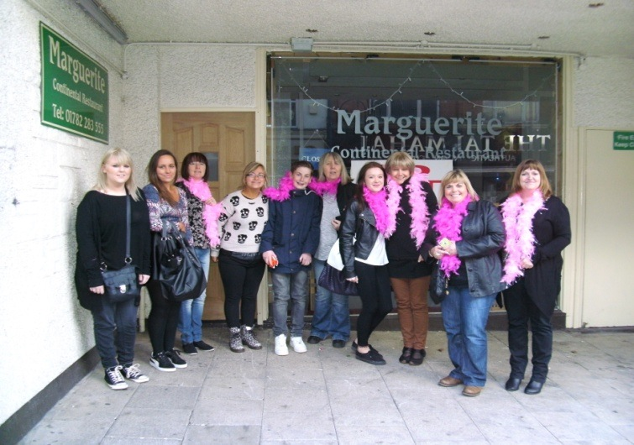
As a reward for their work at New Images Junior Club, volunteers are given
The opportunity to see the `Rocky Horror Show` whenever it is doing the
Circuit. 2013 was one such year making this our fourth visit, the first for this
Particular group. It is one of the few occasions when we get `offers` of help
From members of staff, who themselves are prepared to volunteer and
Supervise !!

NEW IMAGES - Junior Club
Ongoing funding from Winsford Town Council supports this provision, which continues every Friday night. Paid staff are supported by a regular volunteers and senior helpers, plus others who attend as part of an introduction into care, Youth or sport via education/training.

We had 2847 attendances via the 44 sessions delivery, averaging 65 per week. The challenges and demands remain as every with such a varied, diverse group of youngsters, which makes the night totally unpredictable. Apart from the Programme format which remains relatively similar each week – with a turn round of physical activities, art/craft sessions and whenever possible food projects. Seasonal celebrations continue – with a mix of party games to celebrate the occasion, be it Xmas, Halloween or Valentines.

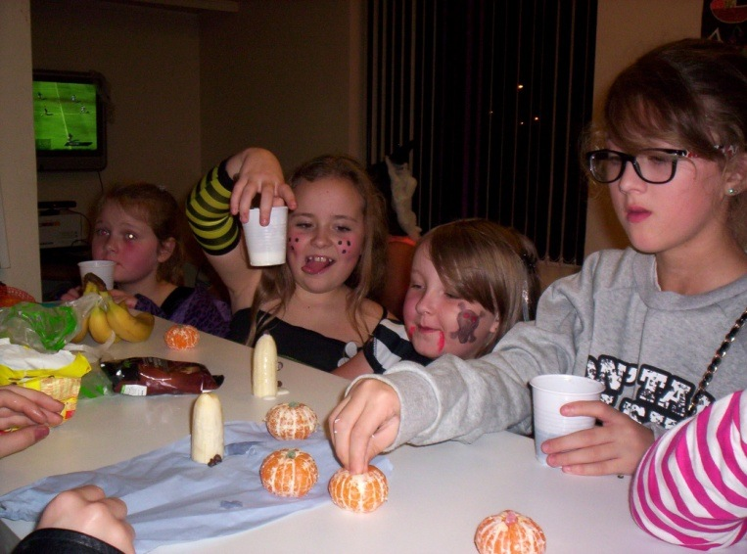
MARINA
Another full programme for this seasonal activity, starting at Easter and going through until October. Funding from Sport England, carried over from the previous year, helped considerable with the costs – supported by the income that we generate via its users. This year we had to employ an additional coach, due to the lack of suitably qualified youngsters coming through the ranks – first time that this has happened for many years. April started slowly, due we believe to the ongoing cold weather – overall we delivered 58 sessions with 82 registered y.p, with 6 adults (parents) actively engaged. Some of the sessions were specific to `group` bookings and support for the Fringe Festival.

WHARTON YOUTH CENTRE.
Funding for our Thursday night session ceased during the summer, leaving CWAC as the only provider of delivery, for several months. With the demise of the Edge we were able to divert funding to reopen, on Thursday, for this popular night, recommenced in November.
Other use included the 4 week summer Play scheme. Three twelve week P.Trust courses run by the Fire Service and Action for Leisure, our adult Special needs group plans to build a bike track to the rear came to an abrupt halt, when the initial exploratory work discovered serious amount of rubble under the top soil. Leaving it in as part of the structure would create an unsafe track, with the likelihood of serious accidents – excavating the site would be extremely costly, so we had no choice but to suspend this project. We delivered 38 Thursday night sessions, with 879 attendances , averaging 23 per session. For a small building with limited space and facilities that is quite an achievement.

WHARTON JUNIOR CLUB (Community Library)
“Junior club members had a discussion as to what they hope they can achieve in 2014”

Continued funding from Weaver Vale Housing Trust supports delivery of this club every Thursday night (except August, due to low numbers and Playscheme provision) Staff here continue to vary the programme every week topical themes, or those related to the funding agreement, or the needs of the Young people. We are fortunate to have a regular staff team here which is a tremendous help with relationships and local knowledge.
We opened for 36 sessions, with 624 attendances for the year
(average 17 per night)
“Staff at the junior preparing for the summer disco”
WHARTON COMMUNITY LIBRARY
Weekend Work - Wharton Community Library –
Provision continued via CWAC funding for Friday and Saturday delivery at this venue. 1016 attendances via 62 sessions, averaging 16 per session. Challenging behaviour is still the main issue within these sessions along with respect for each other. Highly energised teenagers need to have the opportunity to be active – this year we gambled by bringing in a small goal and Foam ball, which has helped to meet their needs, and to a certain extent the Staff`s !
The Edge –
From April – October attendances here were extremely low, limited to a
regular 3-5 y.p, attending as a group. When they did not, and there were many
times, we had none. Further publicity and detached nights, whenever nobody
attended, failed to improve the situation.
This was feed back to CWAC – with a suggestion that one of these nights should be transferred to New Images. In early November the situation, as already stated, with The Edge closing, was resolved for us. Sadly this leaves no provision at this side of the town, making provision at New Images and St Chads their only option. Some have taken up that option.

Community organisers volunteering (picture below) at the Delamere street festival in which St Johns Church celebrate their 150th anniversary. The scarecrows were designed by local schools and rather heavy to carry in the parade.

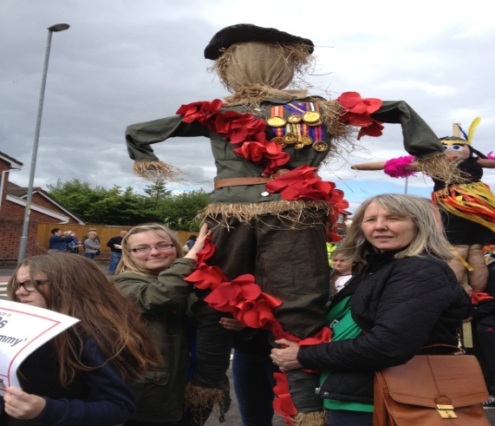

Community Organising –
My priorities for this year were to :
Support the GROW Group (Grange Residents Of Winsford) in their three key priorities. To support their fundraising endeavours to save their youth centre and gain pledges from the local community. To support the incredible edibles group with volunteers and opportunities to chat to local people. To continue door knocking to gain new members, and complete overall picture of the Grange Estate and changes made.
I have had conversations with many people on the Grange and the main 3 priorities for their area were
- New Images Youth Centre
- Environment – look after and care for our open spaces.
3. Local transport issues and isolation of local people.

Below are some of the achievements that as a community organiser for Winsford Youth Forum I have been apart of through listening to local people, making space for them to engage and recruiting volunteers in being part of the change process to take action within their community.
Two Volunteer community organisers of the GROW group gained an award – One received “Volunteer of the Year award” and the other received the Mayor's special Oscars award.
Fairways Play park – Local young people want to present a profile to the council about renovation of the play area. (still in beginning stages this group are fact finding as to who owns the play area)
Little Lights – Parent and toddler group still continues and is self financed as well as gaining free space to use a church community shop space to run. Looking to develop their activities and find funding for new equipment from Local business. I put them forward for an award from Asda last year and they received £250 towards their group.
Football Project - Volunteer community organiser has started a community leaders course and one of his projects was to plan and deliver a community project. Based on some conversations with young people the volunteer organised a “football for all” tournament which involved young people aged 8-16 of all abilities and all levels, from across the town to come together and take part in the day. These young people wanted to be part of this as they were not part of a local football team and wanted to play for the enjoyment of football.
I have raised funds with volunteer community organisers for the Mayors charity to support the Winsford Youth Forum through community prize bingos, bag packs, local businesses offering donations. All this was raised by volunteer community organisers total for the year was £7000 Divided between to charities. Winsford Youth Forum received £3500 Money from the council members budget was allocated for resources to run projects £2200
Local businesses – Roberts Bakery donated £100 for the Grow Group fundraising activities
Asda Total donated £500 - awards of £250 per community organising group which was new images youth centre and little lights
Macdonalds - regularly supports with meal vouchers as prizes towards our bingo
I am confident we can raise future funds to continue community organising.

The GROW group has become a catalyst for the ‘Save new images facebook page’, in which has formed into a group of 500 members all connecting online to discuss local issues. From networking and sharing online we had 12 local people who do not usually attend Council meetings, turned out to a local council meeting to ask questions about the youth centre.
Recently a volunteer community organiser, organised a concert at the youth centre to raise funds for the centre and they were supported by Winsford Youth Forum and Grow group members who gave their time voluntary to provide food and refreshments on the night.
Due to my work as a community Organiser in keeping people informed as to events and activities taking place, this has brought groups across networks to help support each other.
Save Winsford Flashes group formed completely independent of community organising and yet I was having conversations with some of the group members, in which I kept them up to date with neighbourhood plan info.
I supported the Delamere street festival, Riverside festival, Winsford and continue to support Incredible Edibles at Over and Wharton.

Contact

WINSFORD YOUTH FORUM
New Images youth Centre Nixon Drive, Winsford, Cheshire, CW7 2HG
Telephone/Fax: 01606 554649 Mobile 07981955388 Email: bbarton.wyf@gmail.com

President: his grace the duke of Westminster, OBE.TD.DL
Winsford Youth Forum is a Registered Charity (517406) Company Limited by Guarantee (1976247)

